**JAVA SWING BASED – MOOCS Database For Students- SQL CONNECTIVITY USING JDBC**

*A*

*Report*

*Submitted in partial fulfilment of the*

*Requirements for the award of the Degree of*

**BACHELOR OF ENGINEERING**

**IN**

**INFORMATION TECHNOLOGY**

**By**

**P.Abhignya<1602-21-737-001>**

**Under the guidance of Ms B. Leelavathy**



**Department of Information Technology**

**Vasavi College of Engineering (Autonomous)**

**(Affiliated to Osmania University)**

**Ibrahimbagh, Hyderabad-31**

**2022-2023**

**BONAFIDE CERTIFICATE**

This is to certify that this project report titled

‘***MOOC Database***’

is a project work of ***P.Abhignya***

bearing roll no. 1602-21-737-001

who carried out

this project under my supervision

in the IV semester

of the academic year 2022- 2023

Signature Signature

External Examiner Internal Examiner

**ABSTRACT**

The aim of this project is to design and implement a Moocs (Massive Open Online Course) database for students that captures their Moocs per semester and generates a grade for the highest scored certification. The database will be designed to store information about each student, including their name, student ID, and academic program. The Moocs database will also contain information about the Moocs taken by each student, including the name of the course, the semester in which it was taken, the duration of the course, and the grade received by the student**.** The system will allow students to log in and view their Moocs history, including the grades they received for each course. The system will also generate a grade for the highest scored certification for each student, which will be based on the overall grade received for all the courses taken in a semester. The database will also be designed to allow for efficient retrieval of information and scalability to accommodate the increasing number of students and courses.

**REQUIREMENTS:**

Overall 5 tables are required for the ER model representation , they are:

1. Student
2. Course
3. Semester
4. Enrollment
5. Grade

**Table 1: Student**

**Attributes:**

- sid (primary key)

- name (varchar)

- email (varchar)

- contact (number)

- address (varchar)

**Domain Types:**

- sid, contact: integer

- name, email, contact, address: varchar

**Constraints:**

- Primary key: sid

**Table 2: Course**

**Attributes:**

- cid (primary key)

- cname (varchar)

- cdescription (varchar)

- cduration (varchar)

-date_of_registration(date)

-date_of_examination(date)

-platform_name(varchar)

**Domain Types:**

- cid: integer

- cname, cdescription,cduration,platform_name: varchar

-date_of_registration,date_of_examination: date

**Constraints:**

- Primary key: cid

**Table 3: Semester**

**Attributes:**

- semid (primary key)

- semname (varchar)

- startdate (date)

- enddate (date)

**Domain Types:**

- semid: integer

- semname: varchar

- startdate, enddate: date

**Constraints:**

- Primary key: semid

**Table 4: Enrollment**

**Attributes:**

- eid (primary key)

- sid (foreign key references Student table)

- cid (foreign key references Course table)

- semid (foreign key references Semester table)

- enrolldate (date)

**Domain Types:**

- eid: integer

- sid, cid, semid: integer

- enrolldate: date

**Constraints:**

- Primary key: enrollid

- Foreign keys: sid, cid, semid

**Table 5: Grades**

**Attributes:**

- gid (primary key)

- eid (foreign key references Enrollment table)

- certificatename (varchar)

- score (number)

**Domain Types:**

- gid: integer

- enrollid: integer

- certificationname: varchar

- score: number

**Constraints:**

- Primary key: gid

- Foreign key: eid

**MAPPING CARDINALITIES:**

- One student can enroll in multiple courses in a semester.

- One course can have multiple enrollments by students in a semester.

- One semester can have multiple enrollments by students in courses.

- One enrollment can have multiple grades.

- One grade corresponds to one enrollment.

**DESIGN ( ENTITY RELATIONSHIP MODEL ):**

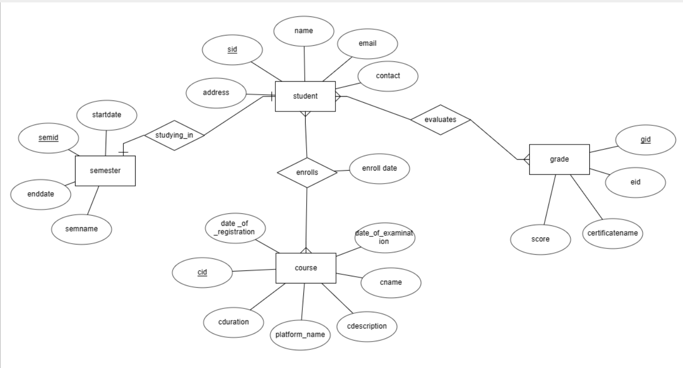

**DDL COMMANDS:**

**Table 1 :Student:**

SQL>create table student(

2 sid number(10),

3 name varchar(10),

4 email varchar(20),

5 contact number(10),

5 address varchar(20),

6 primary key(sid));

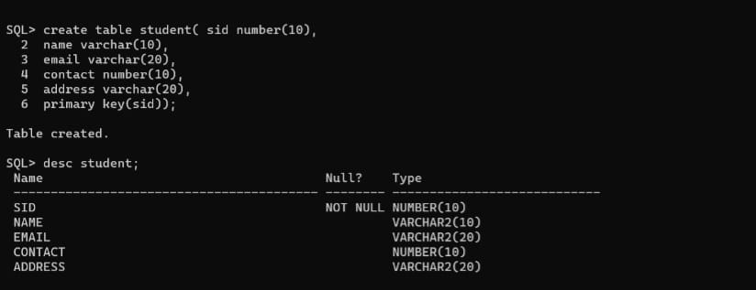

SQL> alter table student modify (email varchar(50));

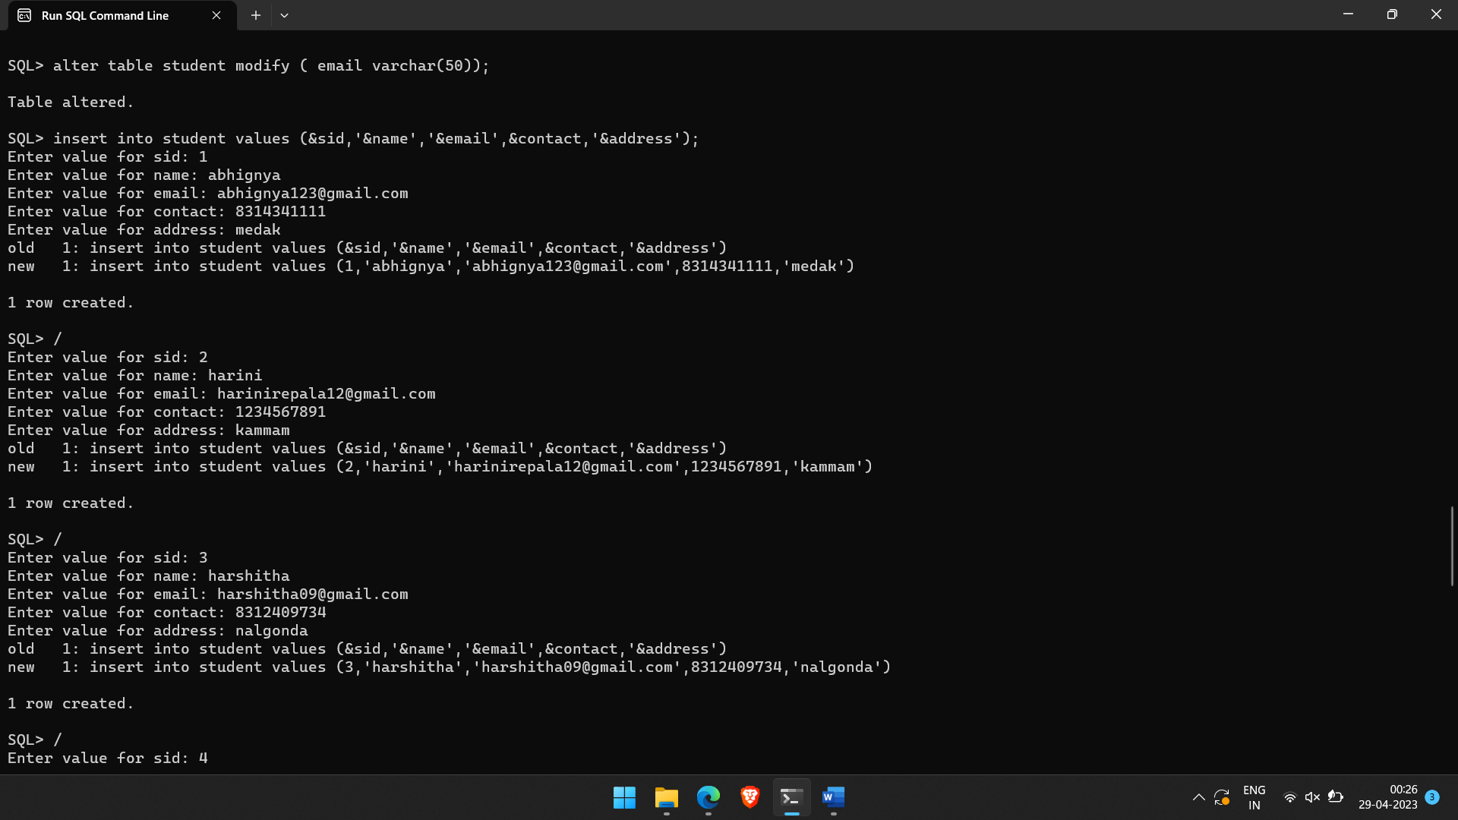

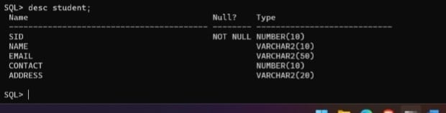

**Table 2: Semester:**

SQL> create table semester(

2 semid number(10),

3 semname varchar(20),

4 startdate date,

5 enddate date);

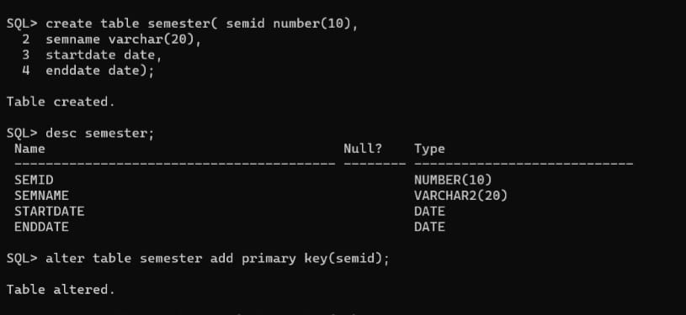

**Table 3:Course:**

SQL> create table course(

2 cid number(10),

3 cname varchar(20),

4 cdescription varchar2(20)

5 cduration number,

Primary key(cid));

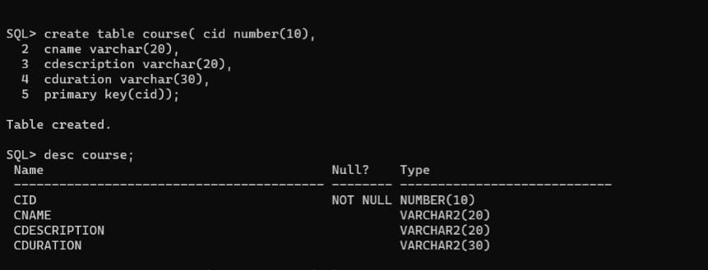

SQL> alter table course modify(cduration number);

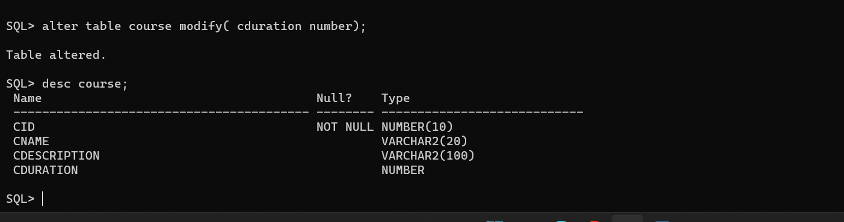

SQL> alter table course add(date_of_registration date, date_of_examination date, platform_name varchar(50));

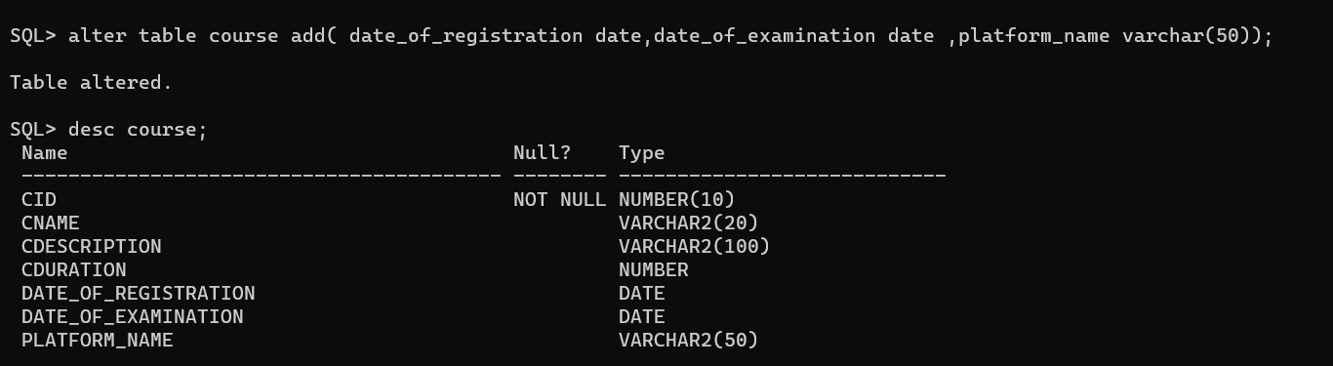

**Table 4: Grade:**

SQL>create table grade(gid number(10),

2 eid number(20),

3 certificatename varchar(30),

4 score number(10),

5 primary key(gid),

6 foreign key (eid) references enrollement ON DELETE CASCADE);

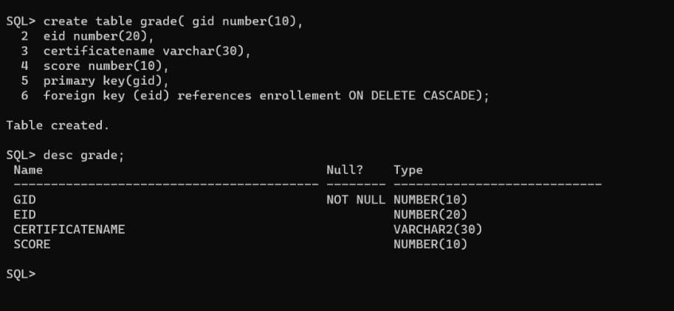

**Table 5: Enrollement:**

SQL>create table enrollement(eid number(20),

2 sid number(10),

3 cid number(10),

4 semid number(10),

5 enrolldate date,

6 primary key(eid),

7 foreign key(sid) references student ON DELETE CASCADE,

8 foreign key(cid) references course ON DELETE CASCADE,

9 foreign key(semid) references semester ON DELETE CASCADE);

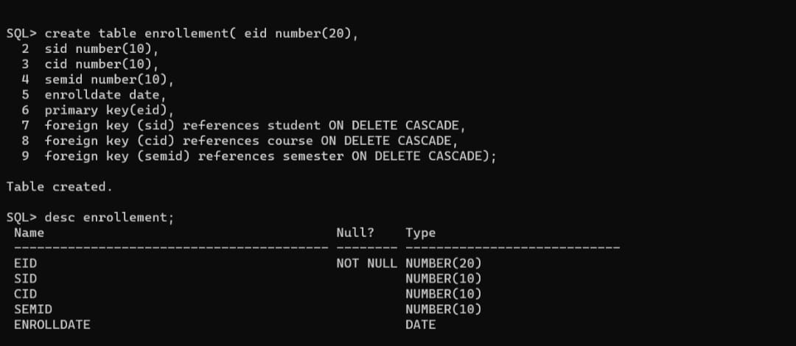

**DML OPERATIONS:**

TABLE 1 : STUDENT

SQL>insert into student values(&sid,’&name’,’&email’,&contact,’&address’);

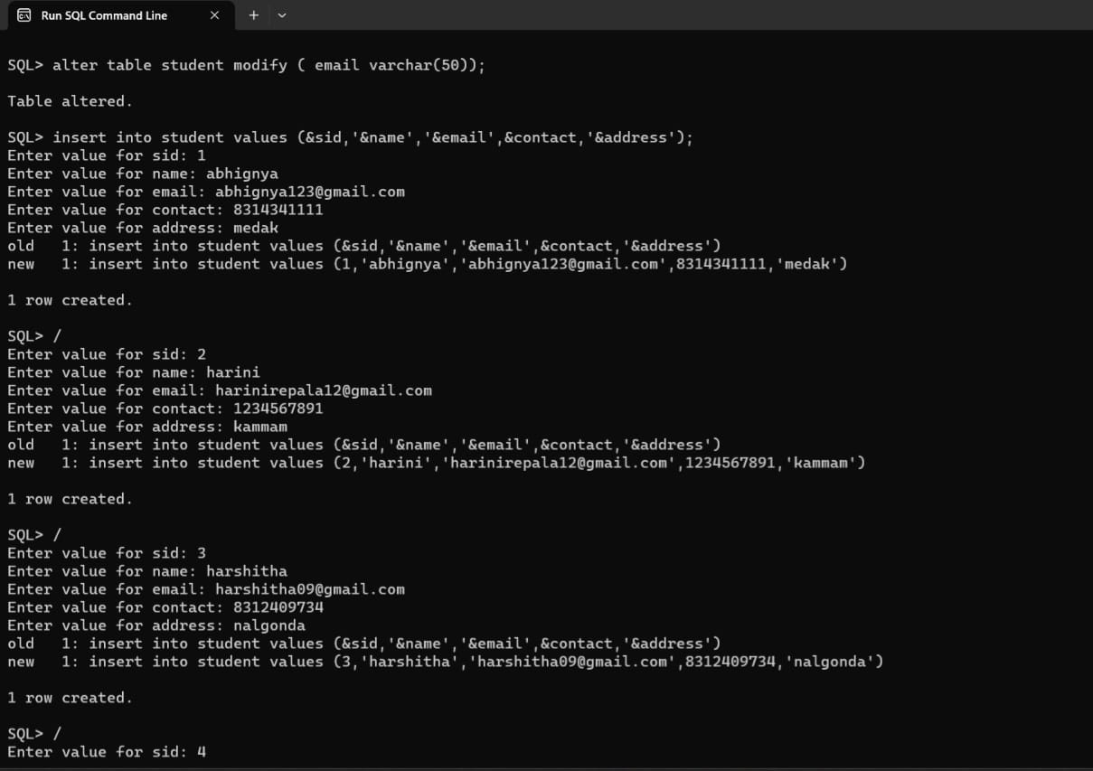

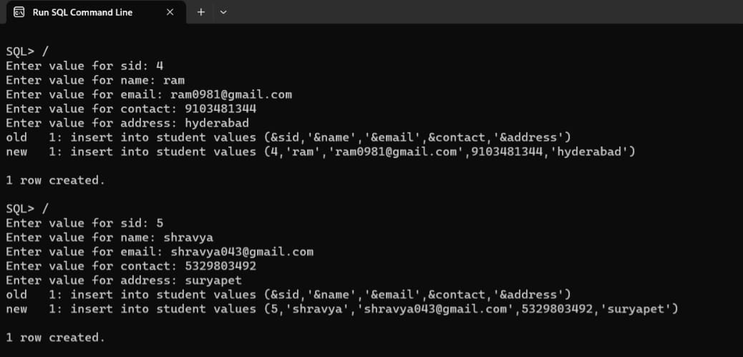

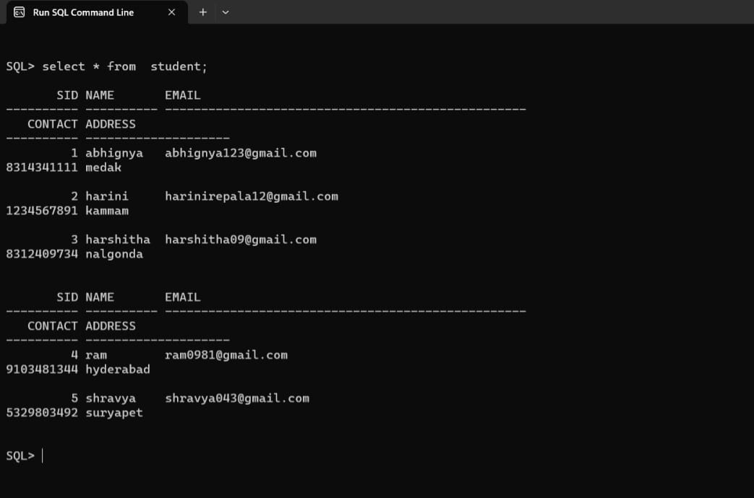

TABLE 2: COURSE

SQL>insert into course values(&cid, ’&cname’ , ‘&cdescription’,&cduration);

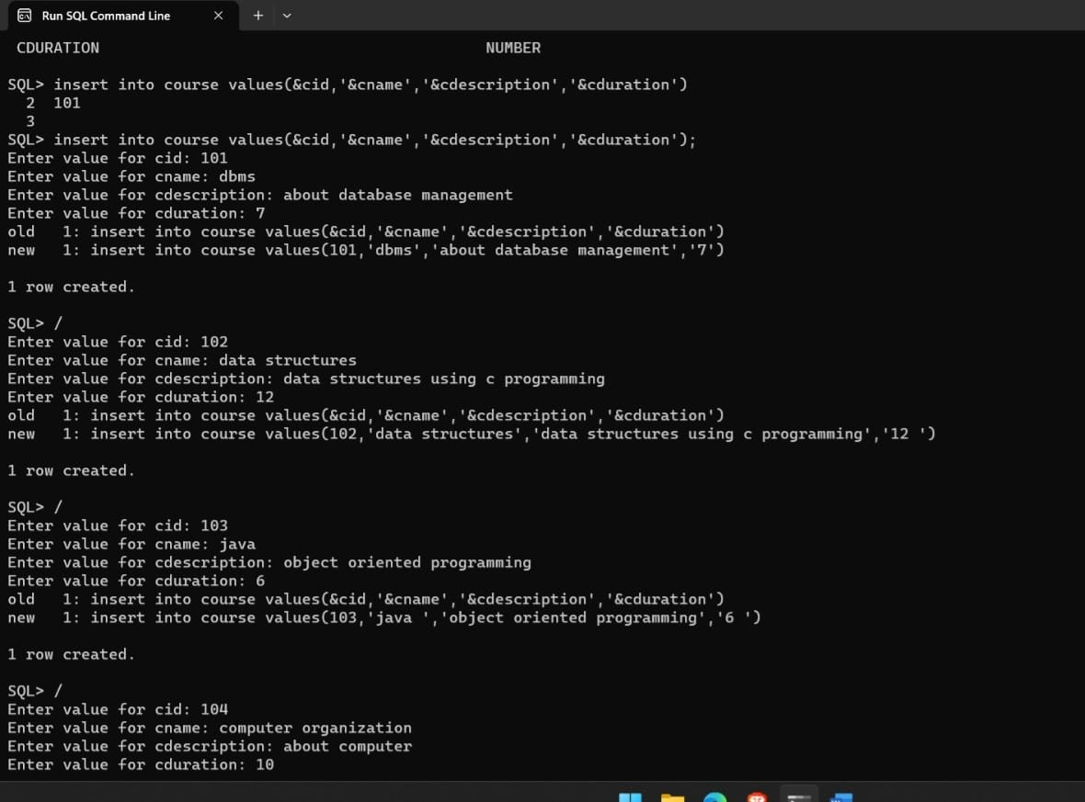

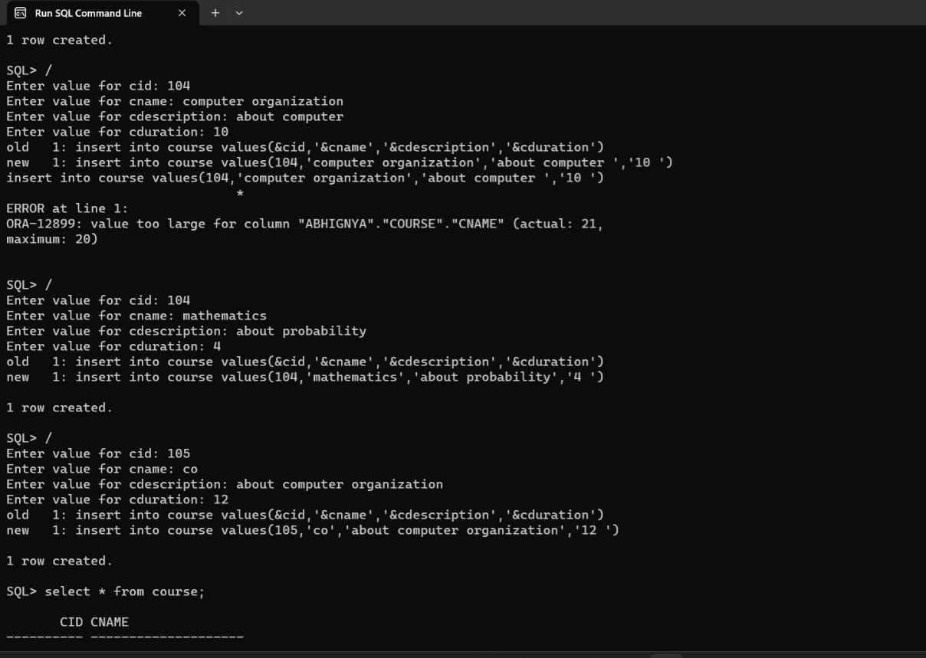

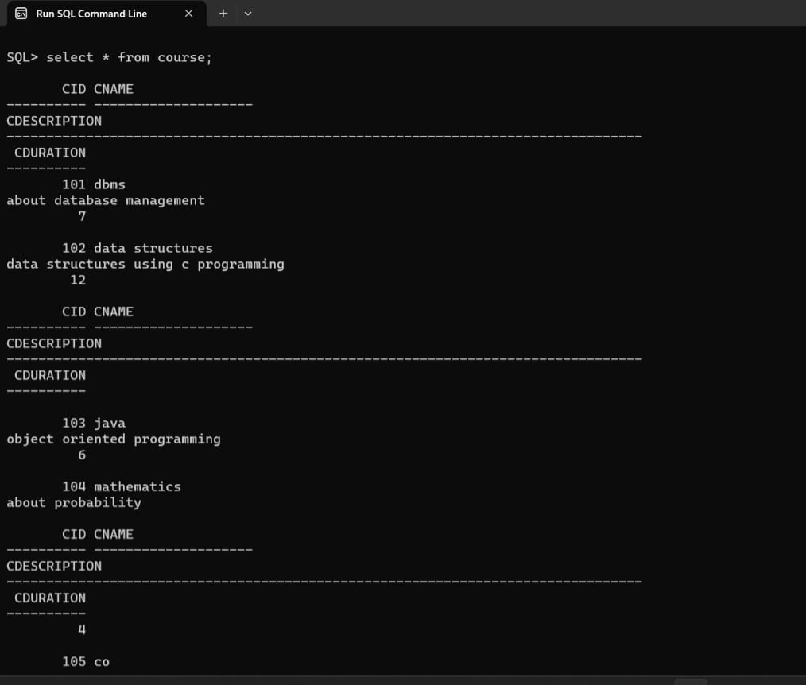

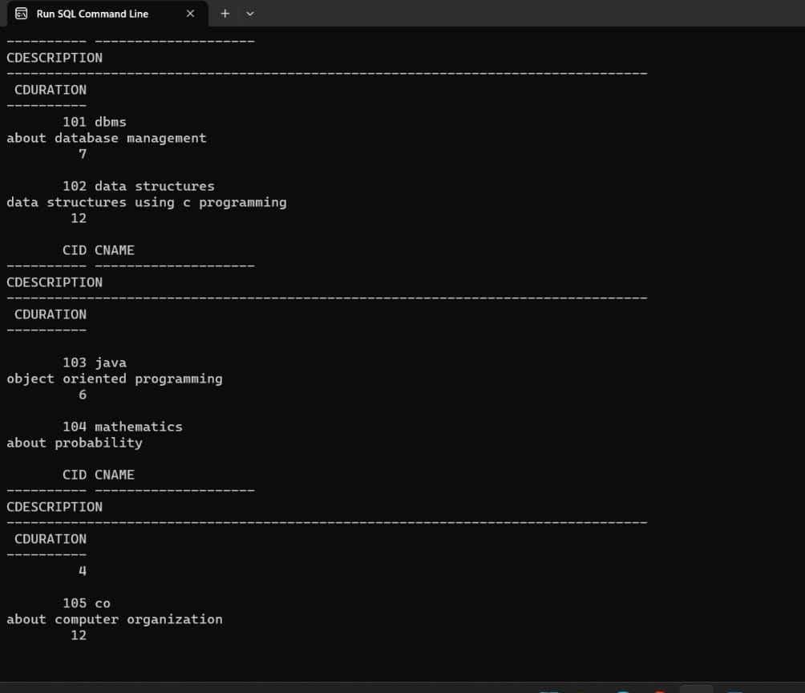

SQL>update course set date_of_examination=&date_of_examination where cid=&cid;

SQL> update course set date_of_registration=&date_of_registration where cid=&cid;

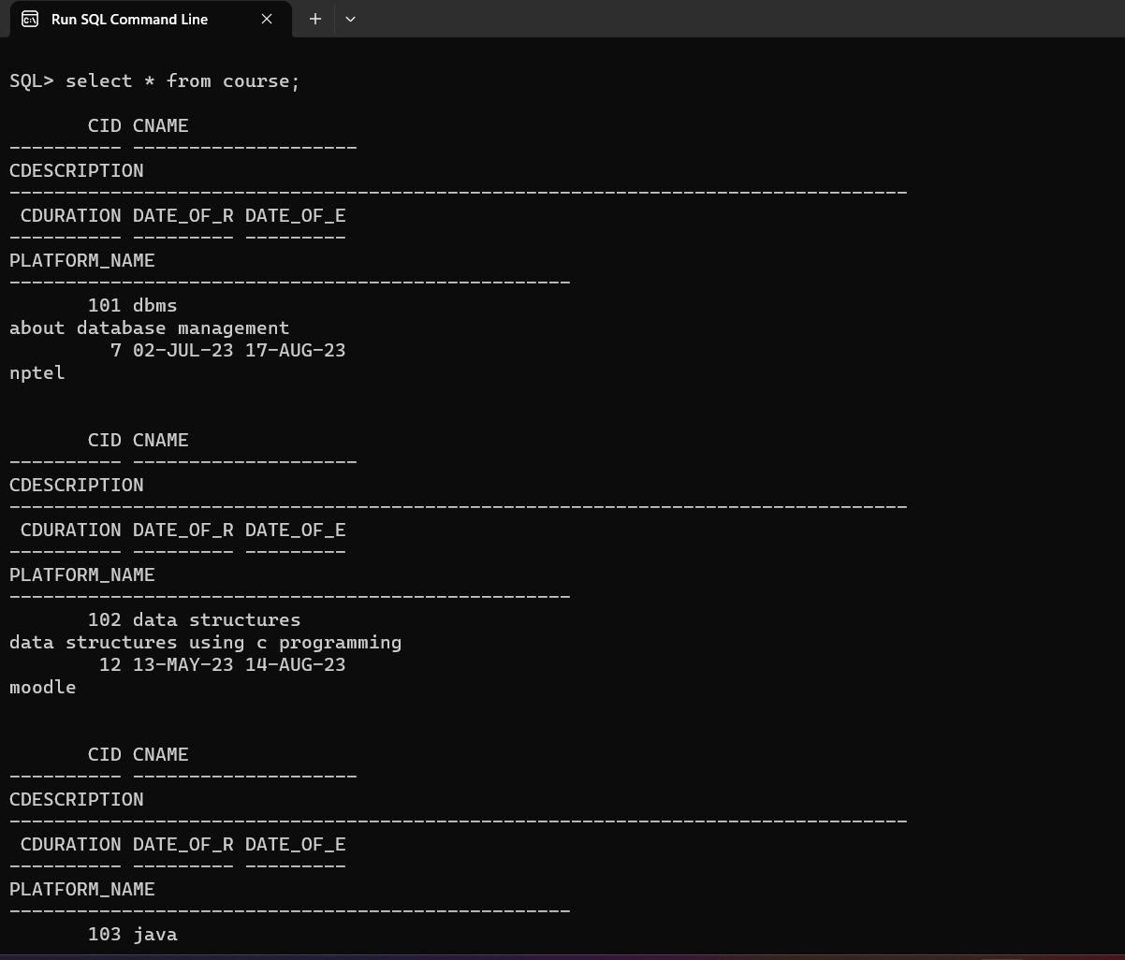

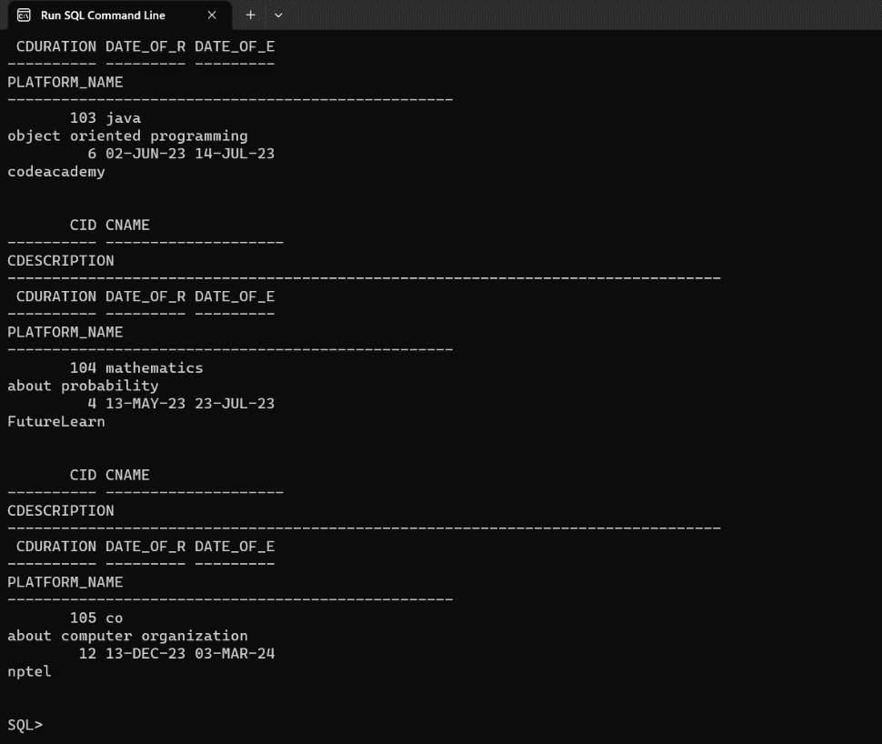

TABLE 3: SEMESTER

SQL>insert into semester values(&semid,’&semname’,&startdate,&enddate);

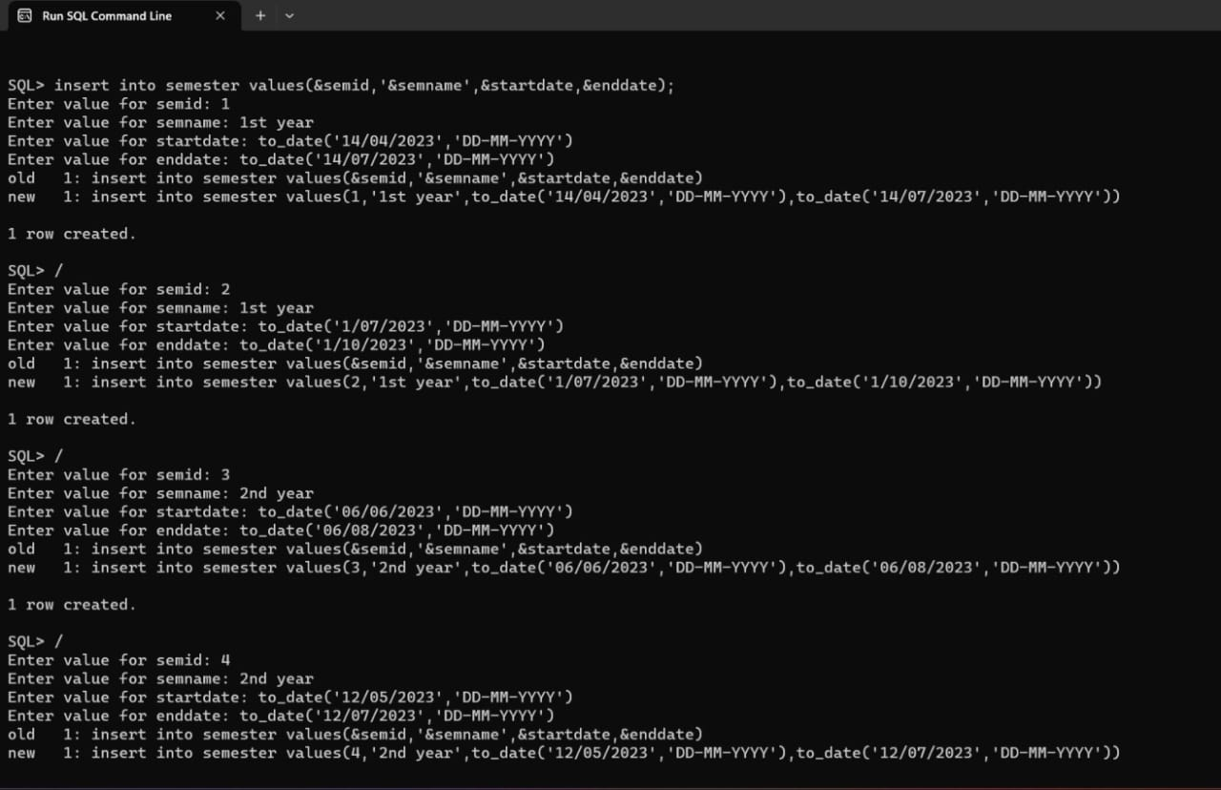

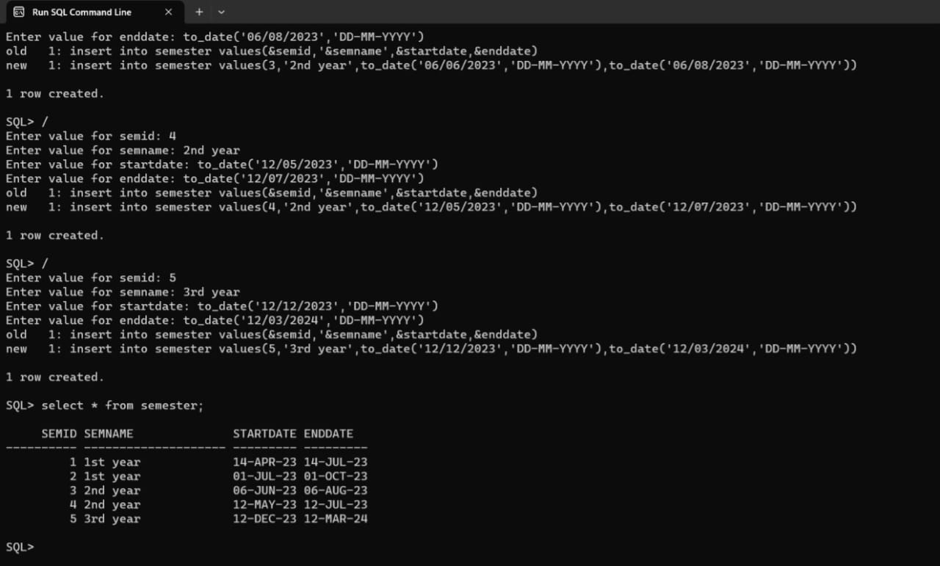

TABLE 4 : ENROLLEMENT

SQL>insert into enrollement values(&eid,&cid,&semid,&enrolldate);

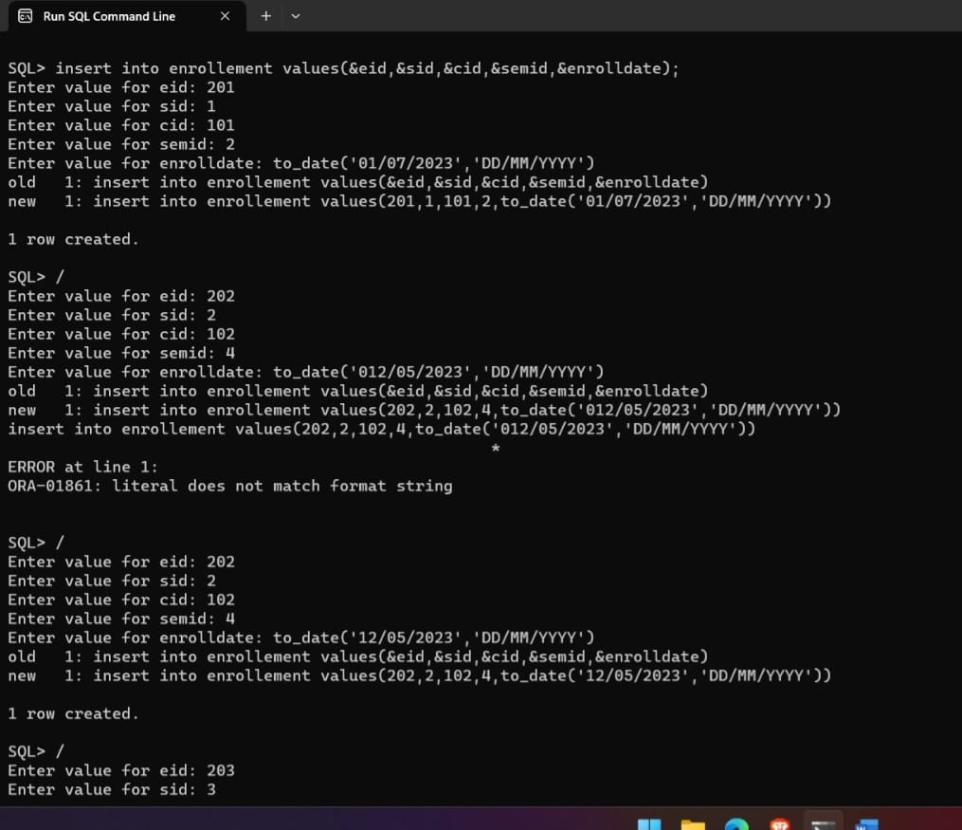

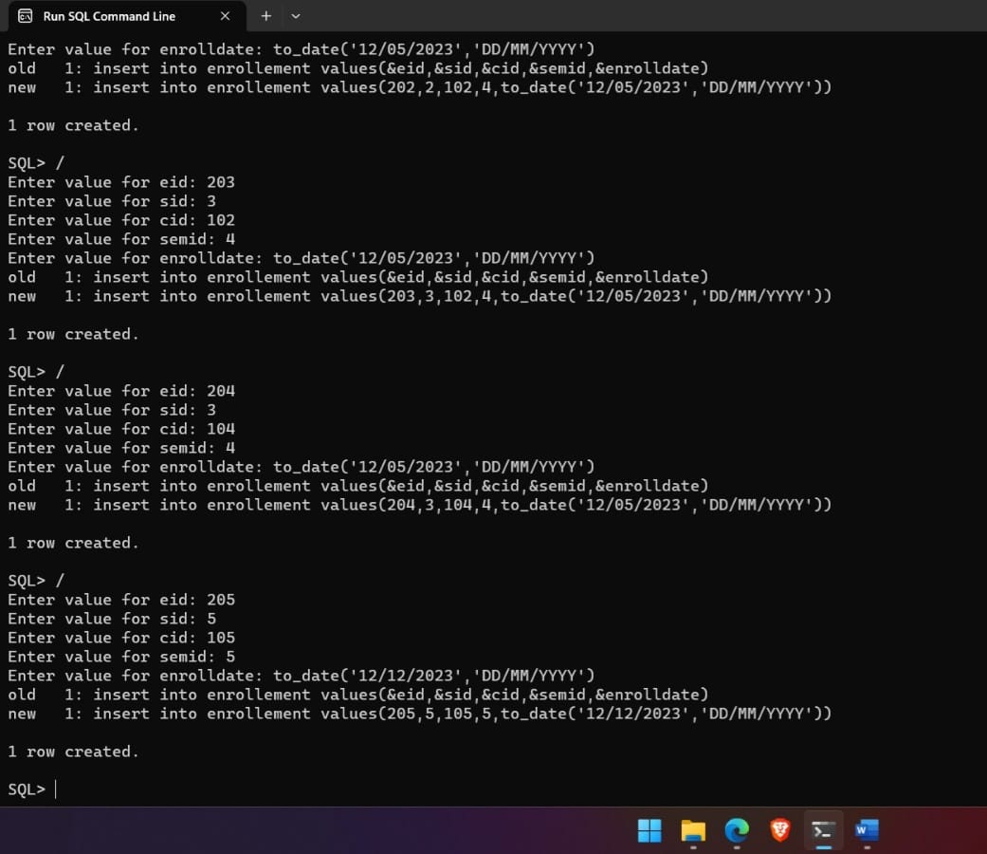

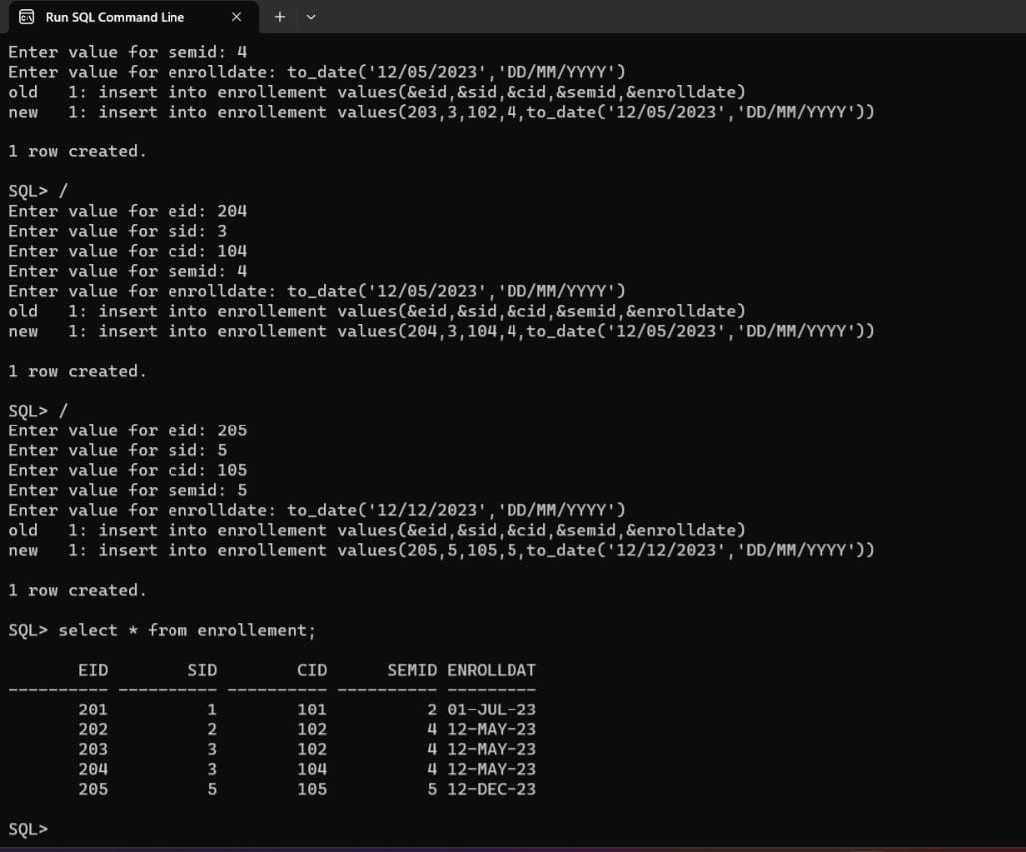

TABLE 5 : GRADE

SQL>insert into grade values(&gid,&eid,’&certificationname’,&score);

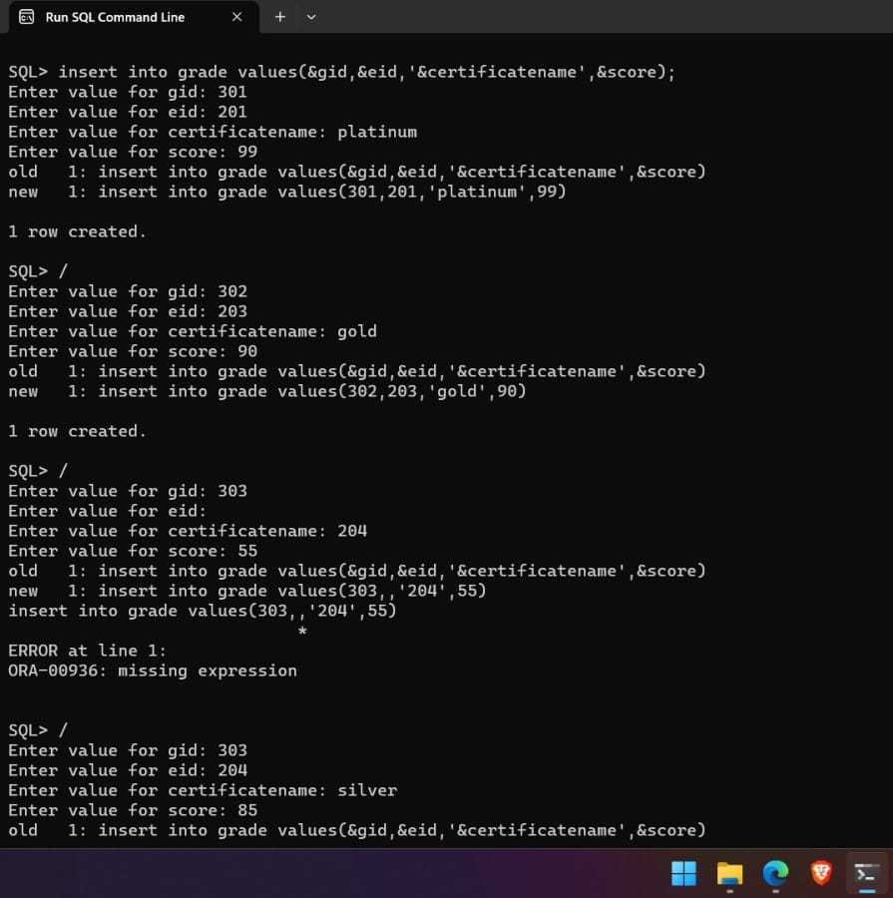

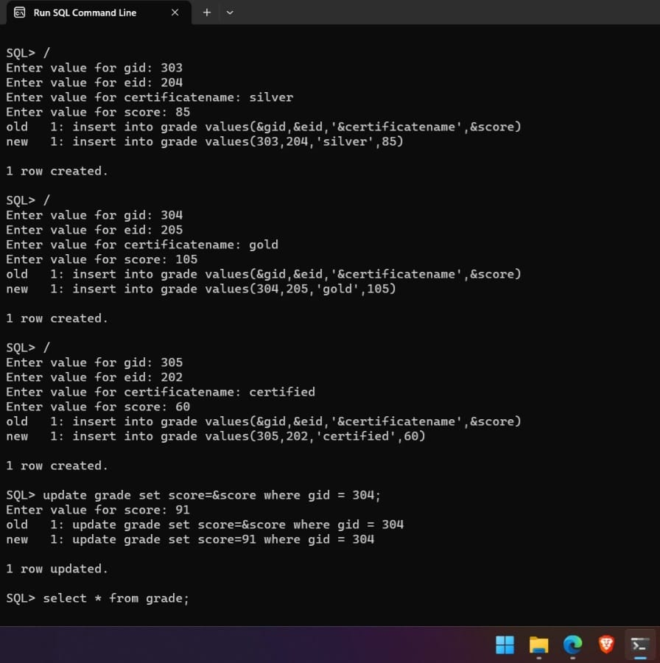

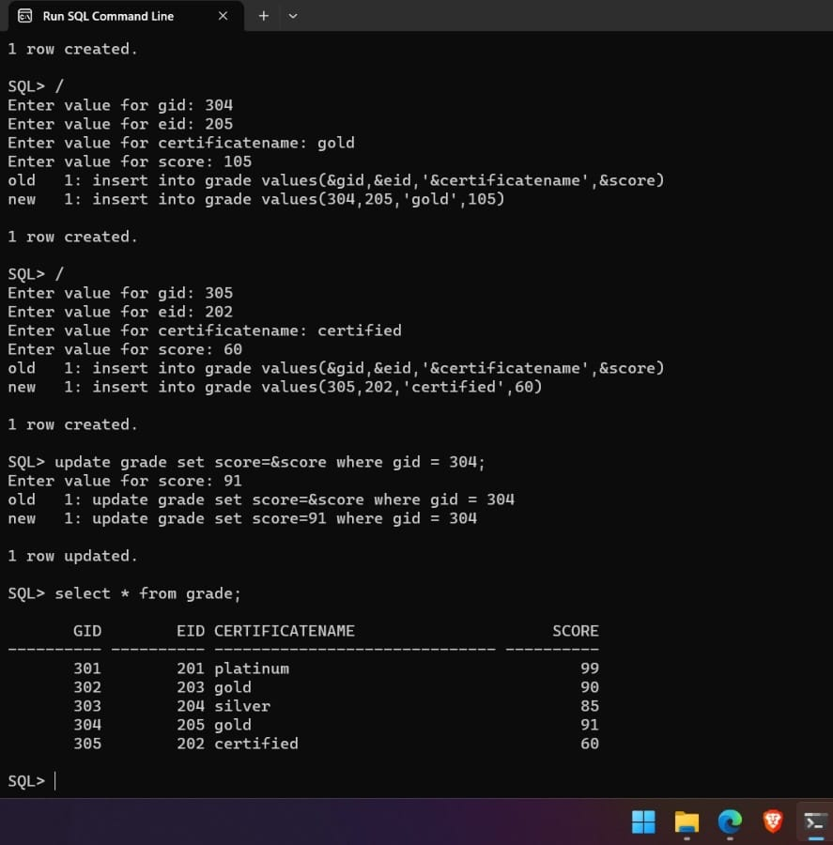

**IMPLEMENTATION**

**JAVA-SQL Connectivity using JDBC:**

**Java Database Connectivity (JDBC)** is an application programming interface (API) for the programming language Java, which defines how a client may access a database. It is a Java-based data access technology used for Java database connectivity. It is part of the Java Standard Edition platform, from Oracle Corporation. It provides methods to query and update data in a database and is oriented towards relational databases.

The connection to the database can be performed using Java programming (JDBC API) as:

package main;

import java.sql.*;

public class ConnectionManager {

private static String url = "jdbc:oracle: thin:@localhost:1521:xe";

private static String username = "abhignya";

private static String password = "abhignya";

private static Connection con;

public static Connection getConnection () throws Exception { con = DriverManager.getConnection (url, username, password);

return con; } }

**Front End Programs**

**1.HOME PAGE:**

**Source Code**

import javax.swing.*;

import java.awt.*;

import java.awt.event.*;

public class MainPage extends JFrame {

private static final long serialVersionUID = 1L;

private JButton retrieveMarksButton;

public MainPage() {

// Set frame properties

setTitle("MOOCs Database");

setDefaultCloseOperation(JFrame.EXIT_ON_CLOSE);

// Create label

JLabel welcomeLabel = new JLabel("Welcome to MOOCs

Database");

welcomeLabel.setFont(new Font("Arial", Font.BOLD, 18));

welcomeLabel.setHorizontalAlignment(SwingConstants.CENTER);

welcomeLabel.setBorder(BorderFactory.createEmptyBorder(20, 0, 20, 0));

add(welcomeLabel, BorderLayout.NORTH);

// Create panel for the button

JPanel buttonPanel = new JPanel();

retrieveMarksButton = new JButton("Retrieve Marks");

buttonPanel.add(retrieveMarksButton);

// Create menu bar

JMenuBar menuBar = new JMenuBar();

// Create menus

JMenu studentMenu = new JMenu("Student Details");

JMenu courseMenu = new JMenu("Course Details");

JMenu enrollmentMenu = new JMenu("Enrollment Details");

JMenu semesterMenu = new JMenu("Semester Details");

JMenu gradeMenu = new JMenu("Grade Details");

// Create menu item for student menu

JMenuItem viewStudentDetails = new JMenuItem("View Student Details");

viewStudentDetails.addActionListener(new ActionListener() {

public void actionPerformed(ActionEvent e) {

new StudentTableGUI();

}

});

// Create menu item for course menu

JMenuItem viewCourseDetails = new JMenuItem("View Course Details");

viewCourseDetails.addActionListener(new ActionListener() {

public void actionPerformed(ActionEvent e) {

new CourseTableGUI();

}

});

// Create menu item for enrollment menu

JMenuItem viewEnrollmentDetails = new JMenuItem("View Enrollment Details");

viewEnrollmentDetails.addActionListener(new ActionListener() {

public void actionPerformed(ActionEvent e) {

new MoocsEnrollmentManagement();

}

});

// Create menu item for semester menu

JMenuItem viewSemesterDetails = new JMenuItem("View Semester Details");

viewSemesterDetails.addActionListener(new ActionListener() {

public void actionPerformed(ActionEvent e) {

new MoocsSemesterGUI();

}

});

// Create menu item for grade menu

JMenuItem viewGradeDetails = new JMenuItem("View Grade Details");

viewGradeDetails.addActionListener(new ActionListener() {

public void actionPerformed(ActionEvent e) {

new MoocsGradeManagement();

}

});

// Create menu item for toppers menu

JMenuItem viewToppersDetails = new JMenuItem("Toppers Details");

viewToppersDetails.addActionListener(new ActionListener() {

public void actionPerformed(ActionEvent e) {

new ToppersList();

}

});

// Add menu items to respective menus

studentMenu.add(viewStudentDetails);

courseMenu.add(viewCourseDetails);

enrollmentMenu.add(viewEnrollmentDetails);

semesterMenu.add(viewSemesterDetails);

gradeMenu.add(viewGradeDetails);

// Add menu item for toppers menu

gradeMenu.add(viewToppersDetails);

// Add menus to the menu bar

menuBar.add(studentMenu);

menuBar.add(courseMenu);

menuBar.add(enrollmentMenu);

menuBar.add(semesterMenu);

menuBar.add(gradeMenu);

// Set the menu bar

setJMenuBar(menuBar);

// Add the button panel to the frame

add(buttonPanel, BorderLayout.CENTER);

// Set button action for "Retrieve Marks"

retrieveMarksButton.addActionListener(new ActionListener() {

public void actionPerformed(ActionEvent e) {

new Retreive();

}

});

// Add window listener to handle maximizing the window

addWindowStateListener(new WindowStateListener() {

public void windowStateChanged(WindowEvent e) {

if ((e.getNewState() & Frame.MAXIMIZED_BOTH) == Frame.MAXIMIZED_BOTH) {

System.out.println("Window maximized");

} else {

System.out.println("Window not maximized");

}

}

});

// Set frame size and visibility

setSize(800, 600);

setVisible(true);

}

public static void main(String[] args) {

new MainPage();

}

}

OUTPUT:

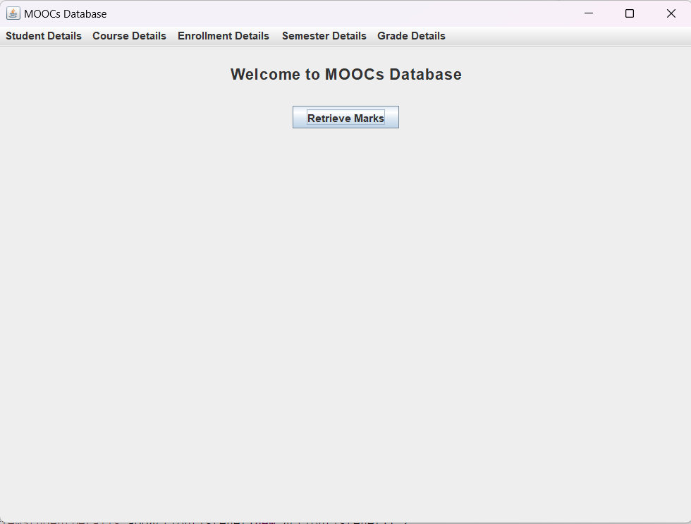

**2.STUDENT**

**Source Code**

import javax.swing.*;

import javax.swing.table.DefaultTableModel;

import java.awt.*;

import java.sql.*;

import java.util.ArrayList;

import java.util.List;

public class StudentTableGUI extends JFrame {

private static final long serialVersionUID = 1L;

private JTextField txtSid, txtName, txtEmail, txtContact, txtAddress;

private JTable tblStudents;

private JButton btnAdd, btnModify, btnDelete, btnDisplay;

private Connection connection;

public StudentTableGUI() {

initializeUI();

connectToDatabase();

displayStudents();

}

private void initializeUI() {

txtSid = new JTextField();

txtName = new JTextField();

txtEmail = new JTextField();

txtContact = new JTextField();

txtAddress = new JTextField();

tblStudents = new JTable();

tblStudents.setSelectionMode(ListSelectionModel.SINGLE_SELECTION);

tblStudents.getSelectionModel().addListSelectionListener(e -> selectStudent());

JScrollPane scrollPane = new JScrollPane(tblStudents);

setDefaultCloseOperation(JFrame.DISPOSE_ON_CLOSE);

btnAdd = new JButton("Add");

btnModify = new JButton("Modify");

btnDelete = new JButton("Delete");

btnDisplay = new JButton("Display");

JPanel panel = new JPanel(new GridBagLayout());

GridBagConstraints gbc = new GridBagConstraints();

gbc.gridx = 0;

gbc.gridy = 0;

gbc.anchor = GridBagConstraints.WEST;

gbc.insets = new Insets(5, 5, 5, 5);

panel.add(new JLabel("SID:"), gbc);

gbc.gridy++;

panel.add(new JLabel("Name:"), gbc);

gbc.gridy++;

panel.add(new JLabel("Email:"), gbc);

gbc.gridy++;

panel.add(new JLabel("Contact:"), gbc);

gbc.gridy++;

panel.add(new JLabel("Address:"), gbc);

gbc.gridx = 1;

gbc.gridy = 0;

gbc.fill = GridBagConstraints.HORIZONTAL;

gbc.weightx = 1;

panel.add(txtSid, gbc);

gbc.gridy++;

panel.add(txtName, gbc);

gbc.gridy++;

panel.add(txtEmail, gbc);

gbc.gridy++;

panel.add(txtContact, gbc);

gbc.gridy++;

panel.add(txtAddress, gbc);

gbc.gridx = 0;

gbc.gridy++;

gbc.gridwidth = 2;

gbc.fill = GridBagConstraints.NONE;

gbc.anchor = GridBagConstraints.CENTER;

gbc.weightx = 0;

panel.add(btnAdd, gbc);

gbc.gridy++;

panel.add(btnModify, gbc);

gbc.gridy++;

panel.add(btnDelete, gbc);

gbc.gridy++;

panel.add(btnDisplay, gbc);

setLayout(new BorderLayout());

add(panel, BorderLayout.NORTH);

add(scrollPane, BorderLayout.CENTER);

btnAdd.addActionListener(e -> insertStudent());

btnModify.addActionListener(e -> modifyStudent());

btnDelete.addActionListener(e -> deleteStudent());

btnDisplay.addActionListener(e -> displayStudents());

setTitle("Moocs Student App");

pack();

setLocationRelativeTo(null);

setVisible(true);

}

private void connectToDatabase() {

String url = "jdbc:oracle:thin:@localhost:1521:xe";

String username = "abhignya";

String password = "abhignya";

try {

connection = DriverManager.getConnection(url, username, password);

} catch (SQLException e) {

e.printStackTrace();

}

}

private void insertStudent() {

String sid = txtSid.getText();

String name = txtName.getText();

String email = txtEmail.getText();

String contact = txtContact.getText();

String address = txtAddress.getText();

try {

String query = "INSERT INTO student (sid, name, email, contact, address) VALUES (?, ?, ?, ?, ?)";

PreparedStatement statement = connection.prepareStatement(query);

statement.setString(1, sid);

statement.setString(2, name);

statement.setString(3, email);

statement.setString(4, contact);

statement.setString(5, address);

statement.executeUpdate();

JOptionPane.showMessageDialog(this, "Successfully inserted");

/*int rowsAffected = statement.executeUpdate();

if (rowsAffected > 0) {

// Display success message

JOptionPane optionPane = new JOptionPane("Student inserted successfully.", JOptionPane.INFORMATION_MESSAGE);

JDialog dialog = optionPane.createDialog(this, "Success");

dialog.setDefaultCloseOperation(JDialog.DISPOSE_ON_CLOSE);

dialog.setVisible(true);

clearFields();

displayStudents();

} else {

// Display failure message

JOptionPane optionPane = new JOptionPane("Failed to insert student.", JOptionPane.ERROR_MESSAGE);

JDialog dialog = optionPane.createDialog(this, "Error");

dialog.setDefaultCloseOperation(JDialog.DISPOSE_ON_CLOSE);

dialog.setVisible(true);}*/

clearFields();

displayStudents();

} catch (SQLException e) {

e.printStackTrace();

}

}

private void modifyStudent() {

int selectedRow = tblStudents.getSelectedRow();

if (selectedRow >= 0) {

String sid = txtSid.getText();

String name = txtName.getText();

String email = txtEmail.getText();

String contact = txtContact.getText();

String address = txtAddress.getText();

try {

String query = "UPDATE student SET name=?, email=?, contact=?, address=? WHERE sid=?";

PreparedStatement statement = connection.prepareStatement(query);

statement.setString(1, name);

statement.setString(2, email);

statement.setString(3, contact);

statement.setString(4, address);

statement.setString(5, sid);

statement.executeUpdate();

int rowsAffected = statement.executeUpdate();

if (rowsAffected > 0) {

JOptionPane.showMessageDialog(this, "Student modified successfully.");

clearFields();

displayStudents();

} else {

JOptionPane.showMessageDialog(this, "Failed to modify student.");

}

clearFields();

displayStudents();

} catch (SQLException e) {

e.printStackTrace();

}

} else {

JOptionPane.showMessageDialog(this, "Please select a student to modify.");

}

}

private void deleteStudent() {

int selectedRow = tblStudents.getSelectedRow();

if (selectedRow >= 0) {

String sid = tblStudents.getValueAt(selectedRow, 0).toString();

int option = JOptionPane.showConfirmDialog(this, "Are you sure you want to delete this student?", "Confirmation", JOptionPane.YES_NO_OPTION);

if (option == JOptionPane.YES_OPTION) {

try {

String query = "DELETE FROM student WHERE sid=?";

PreparedStatement statement = connection.prepareStatement(query);

statement.setString(1, sid);

statement.executeUpdate();

// int rowsAffected = statement.executeUpdate();

JOptionPane.showMessageDialog(this, "Successfully deleted");

/* if (rowsAffected > 0) {

JOptionPane.showMessageDialog(this, "Student deleted successfully.");

clearFields();

displayStudents();

} else {

JOptionPane.showMessageDialog(this, "Failed to delete student.");*/

clearFields();

displayStudents();

}

catch (SQLException e) {

e.printStackTrace();

}

}

} else {

JOptionPane.showMessageDialog(this, "Please select a student to delete.");

}

}

private void displayStudents() {

try {

String query = "SELECT * FROM student";

Statement statement = connection.createStatement();

ResultSet resultSet = statement.executeQuery(query);

List<Student> students = new ArrayList<>();

while (resultSet.next()) {

String sid = resultSet.getString("sid");

String name = resultSet.getString("name");

String email = resultSet.getString("email");

String contact = resultSet.getString("contact");

String address = resultSet.getString("address");

students.add(new Student(sid, name, email, contact, address));

}

DefaultTableModel model = new DefaultTableModel();

model.setColumnIdentifiers(new String[]{"SID", "Name", "Email", "Contact", "Address"});

for (Student student : students) {

model.addRow(new String[]{student.getSid(), student.getName(), student.getEmail(), student.getContact(), student.getAddress()});

}

tblStudents.setModel(model);

} catch (SQLException e) {

e.printStackTrace();

}

}

private void selectStudent() {

int selectedRow = tblStudents.getSelectedRow();

if (selectedRow >= 0) {

String sid = tblStudents.getValueAt(selectedRow, 0).toString();

String name = tblStudents.getValueAt(selectedRow, 1).toString();

String email = tblStudents.getValueAt(selectedRow, 2).toString();

String contact = tblStudents.getValueAt(selectedRow, 3).toString();

String address = tblStudents.getValueAt(selectedRow, 4).toString();

txtSid.setText(sid);

txtName.setText(name);

txtEmail.setText(email);

txtContact.setText(contact);

txtAddress.setText(address);

}

}

private void clearFields() {

txtSid.setText("");

txtName.setText("");

txtEmail.setText("");

txtContact.setText("");

txtAddress.setText("");

}

public static void main(String[] args) {

SwingUtilities.invokeLater(StudentTableGUI::new);

}

private class Student {

private String sid;

private String name;

private String email;

private String contact;

private String address;

public Student(String sid, String name, String email, String contact, String address) {

this.sid = sid;

this.name = name;

this.email = email;

this.contact = contact;

this.address = address;

}

public String getSid() {

return sid;

}

public String getName() {

return name;

}

public String getEmail() {

return email;

}

public String getContact() {

return contact;

}

public String getAddress() {

return address;

}

}

}

OUTPUT:

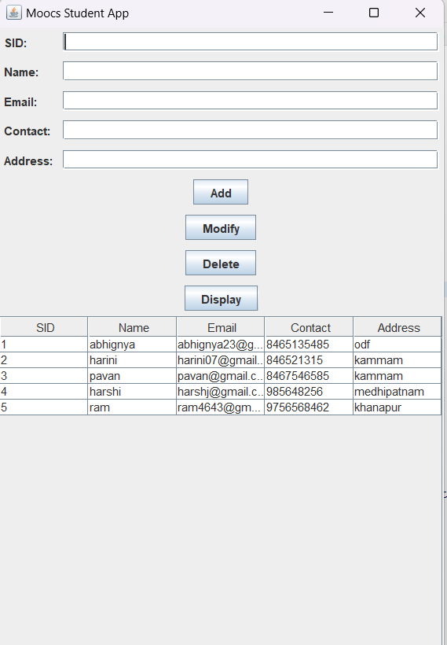

**3.Semester:**

**Source code**

import javax.swing.*;

import javax.swing.table.DefaultTableModel;

import java.awt.*;

import java.sql.*;

import java.util.ArrayList;

import java.util.List;

public class MoocsSemesterGUI extends JFrame {

private static final long serialVersionUID = 1L;

private JTextField txtSemId, txtSemName, txtStartDate, txtEndDate;

private JTable tblSemesters;

private JButton btnAdd, btnModify, btnDelete, btnDisplay;

private Connection connection;

public MoocsSemesterGUI() {

initializeUI();

connectToDatabase();

displaySemesters();

}

private void initializeUI() {

txtSemId = new JTextField();

txtSemName = new JTextField();

txtStartDate = new JTextField();

txtEndDate = new JTextField();

tblSemesters = new JTable();

tblSemesters.setSelectionMode(ListSelectionModel.SINGLE_SELECTION);

tblSemesters.getSelectionModel().addListSelectionListener(e -> selectSemester());

JScrollPane scrollPane = new JScrollPane(tblSemesters);

btnAdd = new JButton("Add");

btnModify = new JButton("Modify");

btnDelete = new JButton("Delete");

btnDisplay = new JButton("Display");

JPanel panel = new JPanel(new GridBagLayout());

GridBagConstraints constraints = new GridBagConstraints();

constraints.anchor = GridBagConstraints.WEST;

constraints.insets = new Insets(5, 5, 5, 5);

// Semester ID

constraints.gridx = 0;

constraints.gridy = 0;

panel.add(new JLabel("Semester ID:"), constraints);

constraints.gridx = 1;

constraints.gridwidth = 3;

constraints.fill = GridBagConstraints.HORIZONTAL;

panel.add(txtSemId, constraints);

// Semester Name

constraints.gridx = 0;

constraints.gridy = 1;

constraints.gridwidth = 1;

constraints.fill = GridBagConstraints.NONE;

panel.add(new JLabel("Semester Name:"), constraints);

constraints.gridx = 1;

constraints.gridwidth = 3;

constraints.fill = GridBagConstraints.HORIZONTAL;

panel.add(txtSemName, constraints);

// Start Date

constraints.gridx = 0;

constraints.gridy = 2;

constraints.gridwidth = 1;

constraints.fill = GridBagConstraints.NONE;

panel.add(new JLabel("Start Date:"), constraints);

constraints.gridx = 1;

constraints.gridwidth = 3;

constraints.fill = GridBagConstraints.HORIZONTAL;

panel.add(txtStartDate, constraints);

// End Date

constraints.gridx = 0;

constraints.gridy = 3;

constraints.gridwidth = 1;

constraints.fill = GridBagConstraints.NONE;

panel.add(new JLabel("End Date:"), constraints);

constraints.gridx = 1;

constraints.gridwidth = 3;

constraints.fill = GridBagConstraints.HORIZONTAL;

panel.add(txtEndDate, constraints);

// Add button

constraints.gridx = 0;

constraints.gridy = 4;

constraints.gridwidth = 2;

constraints.anchor = GridBagConstraints.CENTER;

panel.add(btnAdd, constraints);

// Modify button

constraints.gridx = 2;

panel.add(btnModify, constraints);

// Delete button

constraints.gridx = 0;

constraints.gridy = 5;

panel.add(btnDelete, constraints);

// Display button

constraints.gridx = 2;

panel.add(btnDisplay, constraints);

setLayout(new BorderLayout());

add(panel, BorderLayout.NORTH);

add(scrollPane, BorderLayout.CENTER);

btnAdd.addActionListener(e -> insertSemester());

btnModify.addActionListener(e -> modifySemester());

btnDelete.addActionListener(e -> deleteSemester());

btnDisplay.addActionListener(e -> displaySemesters());

setTitle("Moocs Semester App");

pack();

setLocationRelativeTo(null);

setVisible(true);

}

private void connectToDatabase() {

String url = "jdbc:oracle:thin:@localhost:1521:xe";

String username = "abhignya";

String password = "abhignya";

try {

connection = DriverManager.getConnection(url, username, password);

} catch (SQLException e) {

e.printStackTrace();

}

}

private void insertSemester() {

String semid = txtSemId.getText();

String semname = txtSemName.getText();

String startDate = txtStartDate.getText();

String endDate = txtEndDate.getText();

try {

String query = "INSERT INTO semester (semid, semname, startdate, enddate) VALUES (?, ?, ?, ?)";

PreparedStatement statement = connection.prepareStatement(query);

statement.setString(1, semid);

statement.setString(2, semname);

statement.setString(3, startDate);

statement.setString(4, endDate);

statement.executeUpdate();

clearFields();

displaySemesters();

} catch (SQLException e) {

e.printStackTrace();

}

}

private void modifySemester() {

int selectedRow = tblSemesters.getSelectedRow();

if (selectedRow >= 0) {

String semid = txtSemId.getText();

String semname = txtSemName.getText();

String startDate = txtStartDate.getText();

String endDate = txtEndDate.getText();

try {

String query = "UPDATE semester SET semname=?, startdate=?, enddate=? WHERE semid=?";

PreparedStatement statement = connection.prepareStatement(query);

statement.setString(1, semname);

statement.setString(2, startDate);

statement.setString(3, endDate);

statement.setString(4, semid);

statement.executeUpdate();

clearFields();

displaySemesters();

} catch (SQLException e) {

e.printStackTrace();

}

} else {

JOptionPane.showMessageDialog(this, "Please select a semester to modify.");

}

}

private void deleteSemester() {

int selectedRow = tblSemesters.getSelectedRow();

if (selectedRow >= 0) {

String semid = tblSemesters.getValueAt(selectedRow, 0).toString();

int option = JOptionPane.showConfirmDialog(this, "Are you sure you want to delete this semester?", "Confirmation", JOptionPane.YES_NO_OPTION);

if (option == JOptionPane.YES_OPTION) {

try {

String query = "DELETE FROM semester WHERE semid=?";

PreparedStatement statement = connection.prepareStatement(query);

statement.setString(1, semid);

statement.executeUpdate();

clearFields();

displaySemesters();

} catch (SQLException e) {

e.printStackTrace();

}

}

} else {

JOptionPane.showMessageDialog(this, "Please select a semester to delete.");

}

}

private void displaySemesters() {

try {

String query = "SELECT * FROM semester";

Statement statement = connection.createStatement();

ResultSet resultSet = statement.executeQuery(query);

List<Semester> semesters = new ArrayList<>();

while (resultSet.next()) {

String semid = resultSet.getString("semid");

String semname = resultSet.getString("semname");

String startDate = resultSet.getString("startdate");

String endDate = resultSet.getString("enddate");

semesters.add(new Semester(semid, semname, startDate, endDate));

}

DefaultTableModel model = new DefaultTableModel();

model.setColumnIdentifiers(new String[]{"Semester ID", "Semester Name", "Start Date", "End Date"});

for (Semester semester : semesters) {

model.addRow(new String[]{semester.getSemId(), semester.getSemName(), semester.getStartDate(), semester.getEndDate()});

}

tblSemesters.setModel(model);

} catch (SQLException e) {

e.printStackTrace();

}

}

private void selectSemester() {

int selectedRow = tblSemesters.getSelectedRow();

if (selectedRow >= 0) {

String semid = tblSemesters.getValueAt(selectedRow, 0).toString();

String semname = tblSemesters.getValueAt(selectedRow, 1).toString();

String startDate = tblSemesters.getValueAt(selectedRow, 2).toString();

String endDate = tblSemesters.getValueAt(selectedRow, 3).toString();

txtSemId.setText(semid);

txtSemName.setText(semname);

txtStartDate.setText(startDate);

txtEndDate.setText(endDate);

}

}

private void clearFields() {

txtSemId.setText("");

txtSemName.setText("");

txtStartDate.setText("");

txtEndDate.setText("");

}

public static void main(String[] args) {

SwingUtilities.invokeLater(MoocsSemesterGUI::new);

}

private class Semester {

private String semId;

private String semName;

private String startDate;

private String endDate;

public Semester(String semId, String semName, String startDate, String endDate) {

this.semId = semId;

this.semName = semName;

this.startDate = startDate;

this.endDate = endDate;

}

public String getSemId() {

return semId;

}

public String getSemName() {

return semName;

}

public String getStartDate() {

return startDate;

}

public String getEndDate() {

return endDate;

}

}

}

OUTPUT:

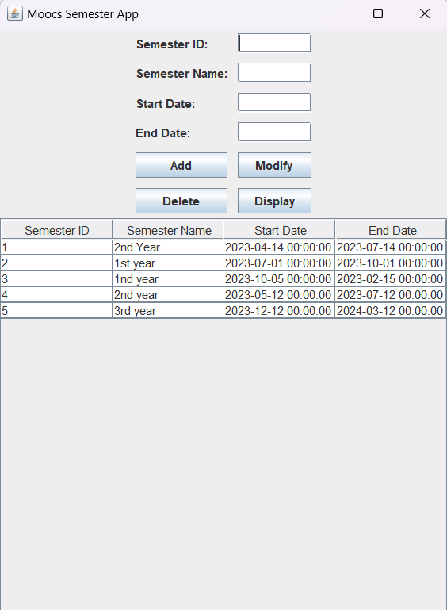

**4.GRADE**

**Source code**

import javax.swing.*;

import javax.swing.table.DefaultTableModel;

import java.awt.*;

import java.sql.*;

import java.util.ArrayList;

import java.util.List;

public class MoocsGradeManagement extends JFrame {

private static final long serialVersionUID = 1L;

private JTextField txtGid, txtEid, txtCertificateName, txtScore;

private JTable tblGrades;

private JButton btnAdd, btnModify, btnDelete, btnDisplay;

private Connection connection;

public MoocsGradeManagement() {

initializeUI();

connectToDatabase();

displayGrades();

}

private void initializeUI() {

txtGid = new JTextField(15);

txtEid = new JTextField(15);

txtCertificateName = new JTextField(15);

txtScore = new JTextField(15);

tblGrades = new JTable();

tblGrades.setSelectionMode(ListSelectionModel.SINGLE_SELECTION);

tblGrades.getSelectionModel().addListSelectionListener(e -> selectGrade());

JScrollPane scrollPane = new JScrollPane(tblGrades);

btnAdd = new JButton("Add");

btnModify = new JButton("Modify");

btnDelete = new JButton("Delete");

btnDisplay = new JButton("Display");

JPanel panel = new JPanel(new GridBagLayout());

GridBagConstraints constraints = new GridBagConstraints();

constraints.anchor = GridBagConstraints.WEST;

constraints.insets = new Insets(5, 5, 5, 5);

constraints.gridx = 0;

constraints.gridy = 0;

panel.add(new JLabel("Grade ID:"), constraints);

constraints.gridx = 1;

panel.add(txtGid, constraints);

constraints.gridx = 0;

constraints.gridy = 1;

panel.add(new JLabel("Enrollment ID:"), constraints);

constraints.gridx = 1;

panel.add(txtEid, constraints);

constraints.gridx = 0;

constraints.gridy = 2;

panel.add(new JLabel("Certificate Name:"), constraints);

constraints.gridx = 1;

panel.add(txtCertificateName, constraints);

constraints.gridx = 0;

constraints.gridy = 3;

panel.add(new JLabel("Score:"), constraints);

constraints.gridx = 1;

panel.add(txtScore, constraints);

constraints.gridx = 0;

constraints.gridy = 4;

constraints.gridwidth = 2;

constraints.anchor = GridBagConstraints.CENTER;

panel.add(btnAdd, constraints);

constraints.gridx = 0;

constraints.gridy = 5;

panel.add(btnModify, constraints);

constraints.gridx = 1;

panel.add(btnDelete, constraints);

constraints.gridx = 0;

constraints.gridy = 6;

constraints.gridwidth = 2;

constraints.anchor = GridBagConstraints.CENTER;

panel.add(btnDisplay, constraints);

setLayout(new BorderLayout());

add(panel, BorderLayout.NORTH);

add(scrollPane, BorderLayout.CENTER);

btnAdd.addActionListener(e -> insertGrade());

btnModify.addActionListener(e -> modifyGrade());

btnDelete.addActionListener(e -> deleteGrade());

btnDisplay.addActionListener(e -> displayGrades());

setTitle("Moocs Grade Management");

pack();

setLocationRelativeTo(null);

setVisible(true);

}

private void connectToDatabase() {

String url = "jdbc:oracle:thin:@localhost:1521:xe";

String username = "abhignya";

String password = "abhignya";

try {

connection = DriverManager.getConnection(url, username, password);

} catch (SQLException e) {

e.printStackTrace();

}

}

private void insertGrade() {

String gid = txtGid.getText();

String eid = txtEid.getText();

String certificateName = txtCertificateName.getText();

String score = txtScore.getText();

try {

String query = "INSERT INTO grade (gid, eid, certificatename, score) VALUES (?, ?, ?, ?)";

PreparedStatement statement = connection.prepareStatement(query);

statement.setString(1, gid);

statement.setString(2, eid);

statement.setString(3, certificateName);

statement.setString(4, score);

statement.executeUpdate();

clearFields();

displayGrades();

} catch (SQLException e) {

e.printStackTrace();

}

}

private void modifyGrade() {

int selectedRow = tblGrades.getSelectedRow();

if (selectedRow >= 0) {

String gid = txtGid.getText();

String eid = txtEid.getText();

String certificateName = txtCertificateName.getText();

String score = txtScore.getText();

try {

String query = "UPDATE grade SET eid=?, certificatename=?, score=? WHERE gid=?";

PreparedStatement statement = connection.prepareStatement(query);

statement.setString(1, eid);

statement.setString(2, certificateName);

statement.setString(3, score);

statement.setString(4, gid);

statement.executeUpdate();

clearFields();

displayGrades();

} catch (SQLException e) {

e.printStackTrace();

}

} else {

JOptionPane.showMessageDialog(this, "Please select a grade to modify.");

}

}

private void deleteGrade() {

int selectedRow = tblGrades.getSelectedRow();

if (selectedRow >= 0) {

String gid = tblGrades.getValueAt(selectedRow, 0).toString();

int option = JOptionPane.showConfirmDialog(this, "Are you sure you want to delete this grade?", "Confirmation", JOptionPane.YES_NO_OPTION);

if (option == JOptionPane.YES_OPTION) {

try {

String query = "DELETE FROM grade WHERE gid=?";

PreparedStatement statement = connection.prepareStatement(query);

statement.setString(1, gid);

statement.executeUpdate();

clearFields();

displayGrades();

} catch (SQLException e) {

e.printStackTrace();

}

}

} else {

JOptionPane.showMessageDialog(this, "Please select a grade to delete.");

}

}

private void displayGrades() {

try {

String query = "SELECT * FROM grade";

Statement statement = connection.createStatement();

ResultSet resultSet = statement.executeQuery(query);

List<Grade> grades = new ArrayList<>();

while (resultSet.next()) {

String gid = resultSet.getString("gid");

String eid = resultSet.getString("eid");

String certificateName = resultSet.getString("certificatename");

String score = resultSet.getString("score");

grades.add(new Grade(gid, eid, certificateName, score));

}

DefaultTableModel model = new DefaultTableModel();

model.setColumnIdentifiers(new String[]{"Grade ID", "Enrollment ID", "Certificate Name", "Score"});

for (Grade grade : grades) {

model.addRow(new String[]{grade.getGid(), grade.getEid(), grade.getCertificateName(), grade.getScore()});

}

tblGrades.setModel(model);

} catch (SQLException e) {

e.printStackTrace();

}

}

private void selectGrade() {

int selectedRow = tblGrades.getSelectedRow();

if (selectedRow >= 0) {

String gid = tblGrades.getValueAt(selectedRow, 0).toString();

String eid = tblGrades.getValueAt(selectedRow, 1).toString();

String certificateName = tblGrades.getValueAt(selectedRow, 2).toString();

String score = tblGrades.getValueAt(selectedRow, 3).toString();

txtGid.setText(gid);

txtEid.setText(eid);

txtCertificateName.setText(certificateName);

txtScore.setText(score);

}

}

private void clearFields() {

txtGid.setText("");

txtEid.setText("");

txtCertificateName.setText("");

txtScore.setText("");

}

public static void main(String[] args) {

SwingUtilities.invokeLater(MoocsGradeManagement::new);

}

private class Grade {

private String gid;

private String eid;

private String certificateName;

private String score;

public Grade(String gid, String eid, String certificateName, String score) {

this.gid = gid;

this.eid = eid;

this.certificateName = certificateName;

this.score = score;

}

public String getGid() {

return gid;

}

public String getEid() {

return eid;

}

public String getCertificateName() {

return certificateName;

}

public String getScore() {

return score;

}

}

}

OUTPUT:

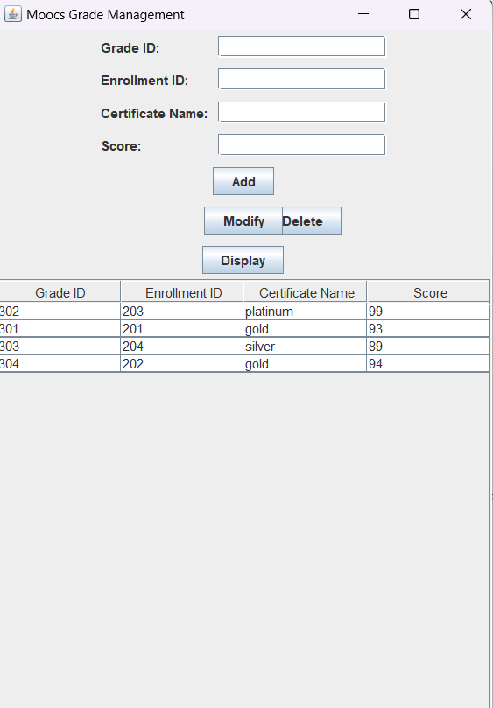

**5.ENROLLEMENT:**

**Source code**

import javax.swing.*;

import javax.swing.event.ListSelectionEvent;

import javax.swing.event.ListSelectionListener;

import javax.swing.table.DefaultTableModel;

import java.awt.*;

import java.awt.event.ActionEvent;

import java.awt.event.ActionListener;

import java.sql.*;

import java.util.ArrayList;

import java.util.List;

import java.text.DateFormat;

import java.text.ParseException;

import java.text.SimpleDateFormat;

public class MoocsEnrollmentManagement extends JFrame {

private static final long serialVersionUID = 1L;

private JTextField txtEnrollId, txtEnrollDate, txtSemesterId, txtCourseId, txtStudentId;

private JTable tblEnrollments;

private JButton btnAdd, btnModify, btnDelete, btnDisplay;

private Connection connection;

public MoocsEnrollmentManagement() {

initializeUI();

connectToDatabase();

displayEnrollments();

}

private void initializeUI() {

txtEnrollId = new JTextField();

txtEnrollDate = new JTextField();

txtSemesterId = new JTextField();

txtCourseId = new JTextField();

txtStudentId = new JTextField();

tblEnrollments = new JTable();

tblEnrollments.setSelectionMode(ListSelectionModel.SINGLE_SELECTION);

tblEnrollments.getSelectionModel().addListSelectionListener(new ListSelectionListener() {

public void valueChanged(ListSelectionEvent e) {

selectEnrollment();

}

});

JScrollPane scrollPane = new JScrollPane(tblEnrollments);

btnAdd = new JButton("Add");

btnModify = new JButton("Modify");

btnDelete = new JButton("Delete");

btnDisplay = new JButton("Display");

JPanel panel = new JPanel(new GridLayout(7, 2));

panel.add(new JLabel("Enroll ID:"));

panel.add(txtEnrollId);

panel.add(new JLabel("Enroll Date:"));

panel.add(txtEnrollDate);

panel.add(new JLabel("Semester ID:"));

panel.add(txtSemesterId);

panel.add(new JLabel("Course ID:"));

panel.add(txtCourseId);

panel.add(new JLabel("Student ID:"));

panel.add(txtStudentId);

panel.add(btnAdd);

panel.add(btnModify);

panel.add(btnDelete);

panel.add(btnDisplay);

setLayout(new BorderLayout());

add(panel, BorderLayout.NORTH);

add(scrollPane, BorderLayout.CENTER);

btnAdd.addActionListener(new ActionListener() {

public void actionPerformed(ActionEvent e) {

insertEnrollment();

}

});

btnModify.addActionListener(new ActionListener() {

public void actionPerformed(ActionEvent e) {

modifyEnrollment();

}

});

btnDelete.addActionListener(new ActionListener() {

public void actionPerformed(ActionEvent e) {

deleteEnrollment();

}

});

btnDisplay.addActionListener(new ActionListener() {

public void actionPerformed(ActionEvent e) {

displayEnrollments();

}

});

setTitle("Moocs Enrollment App");

pack();

setLocationRelativeTo(null);

setVisible(true);

}

private void connectToDatabase() {

String url = "jdbc:oracle:thin:@localhost:1521:xe";

String username = "abhignya";

String password = "abhignya";

try {

connection = DriverManager.getConnection(url, username, password);

} catch (SQLException e) {

e.printStackTrace();

}

}

private void insertEnrollment() {

String enrollId = txtEnrollId.getText();

String enrollDate = txtEnrollDate.getText();

String semesterId = txtSemesterId.getText();

String courseId = txtCourseId.getText();

String studentId = txtStudentId.getText();

try {

String query = "INSERT INTO enrollement (eid, enrolldate, semid, cid, sid) VALUES (?, ?, ?, ?, ?)";

PreparedStatement statement = connection.prepareStatement(query);

statement.setString(1, enrollId);

statement.setString(2, enrollDate);

statement.setString(3, semesterId);

statement.setString(4, courseId);

statement.setString(5, studentId);

statement.executeUpdate();

clearFields();

displayEnrollments();

} catch (SQLException e) {

e.printStackTrace();

}

}

private void modifyEnrollment() {

int selectedRow = tblEnrollments.getSelectedRow();

if (selectedRow >= 0) {

String enrollId = txtEnrollId.getText();

String enrollDate = txtEnrollDate.getText();

String semesterId = txtSemesterId.getText();

String courseId = txtCourseId.getText();

String studentId = txtStudentId.getText();

try {

DateFormat dateFormat = new SimpleDateFormat("yyyy-MM-dd");

java.util.Date parsedDate = dateFormat.parse(enrollDate);

java.sql.Date sqlDate = new java.sql.Date(parsedDate.getTime());

String query = "UPDATE enrollement SET enrolldate=?, semid=?, cid=?, sid=? WHERE eid=?";

PreparedStatement statement = connection.prepareStatement(query);

statement.setDate(1, sqlDate);

statement.setString(2, semesterId);

statement.setString(3, courseId);

statement.setString(4, studentId);

statement.setString(5, enrollId);

statement.executeUpdate();

clearFields();

displayEnrollments();

} catch (ParseException e) {

e.printStackTrace();

} catch (SQLException e) {

e.printStackTrace();

}

}

}

private void deleteEnrollment() {

int selectedRow = tblEnrollments.getSelectedRow();

if (selectedRow >= 0) {

String enrollId = txtEnrollId.getText();

try {

String query = "DELETE FROM enrollement WHERE eid=?";

PreparedStatement statement = connection.prepareStatement(query);

statement.setString(1, enrollId);

statement.executeUpdate();

clearFields();

displayEnrollments();

} catch (SQLException e) {

e.printStackTrace();

}

}

}

private void selectEnrollment() {

int selectedRow = tblEnrollments.getSelectedRow();

if (selectedRow >= 0) {

String enrollId = tblEnrollments.getValueAt(selectedRow, 0).toString();

String enrollDate = tblEnrollments.getValueAt(selectedRow, 1).toString();

String semesterId = tblEnrollments.getValueAt(selectedRow, 2).toString();

String courseId = tblEnrollments.getValueAt(selectedRow, 3).toString();

String studentId = tblEnrollments.getValueAt(selectedRow, 4).toString();

txtEnrollId.setText(enrollId);

txtEnrollDate.setText(enrollDate);

txtSemesterId.setText(semesterId);

txtCourseId.setText(courseId);

txtStudentId.setText(studentId);

}

}

private void displayEnrollments() {

try {

String query = "SELECT * FROM enrollement";

Statement statement = connection.createStatement();

ResultSet resultSet = statement.executeQuery(query);

List<Enrollment> enrollments = new ArrayList<>();

while (resultSet.next()) {

String enrollId = resultSet.getString("eid");

String enrollDate = resultSet.getString("enrolldate");

String semesterId = resultSet.getString("semid");

String courseId = resultSet.getString("cid");

String studentId = resultSet.getString("sid");

enrollments.add(new Enrollment(enrollId, enrollDate, semesterId, courseId, studentId));

}

DefaultTableModel model = new DefaultTableModel();

model.addColumn("Enroll ID");

model.addColumn("Enroll Date");

model.addColumn("Semester ID");

model.addColumn("Course ID");

model.addColumn("Student ID");

for (Enrollment enrollment : enrollments) {

model.addRow(new Object[]{enrollment.getEnrollId(), enrollment.getEnrollDate(), enrollment.getSemesterId(),

enrollment.getCourseId(), enrollment.getStudentId()});

}

tblEnrollments.setModel(model);

} catch (SQLException e) {

e.printStackTrace();

}

}

private void clearFields() {

txtEnrollId.setText("");

txtEnrollDate.setText("");

txtSemesterId.setText("");

txtCourseId.setText("");

txtStudentId.setText("");

}

public static void main(String[] args) {

SwingUtilities.invokeLater(new Runnable() {

public void run() {

new MoocsEnrollmentManagement();

}

});

}

private class Enrollment {

private String enrollId;

private String enrollDate;

private String semesterId;

private String courseId;

private String studentId;

public Enrollment(String enrollId, String enrollDate, String semesterId, String courseId, String studentId) {

this.enrollId = enrollId;

this.enrollDate = enrollDate;

this.semesterId = semesterId;

this.courseId = courseId;

this.studentId = studentId;

}

public String getEnrollId() {

return enrollId;

}

public String getEnrollDate() {

return enrollDate;

}

public String getSemesterId() {

return semesterId;

}

public String getCourseId() {

return courseId;

}

public String getStudentId() {

return studentId;

}

}

}

OUTPUT:

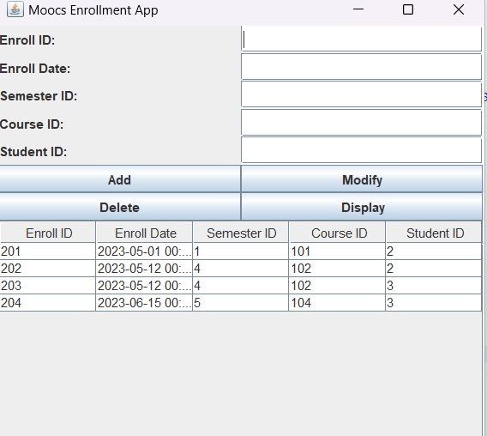

**6.COURSE :**

**Source code**

import javax.swing.*;

import javax.swing.table.DefaultTableModel;

import java.awt.*;

import java.sql.*;

import java.util.ArrayList;

import java.util.List;

public class CourseTableGUI extends JFrame {

private static final long serialVersionUID = 1L;

private JTextField txtCid, txtCname, txtCdescription, txtCduration;

private JTable tblCourses;

private JButton btnAdd, btnModify, btnDelete, btnDisplay;

private Connection connection;

public CourseTableGUI() {

initializeUI();

connectToDatabase();

displayCourses();

}

private void initializeUI() {

txtCid = new JTextField();

txtCid.setColumns(15);

txtCname = new JTextField();

txtCname.setColumns(15);

txtCdescription = new JTextField();

txtCdescription.setColumns(15);

txtCduration = new JTextField();

txtCduration.setColumns(15);

tblCourses = new JTable();

tblCourses.setSelectionMode(ListSelectionModel.SINGLE_SELECTION);

tblCourses.getSelectionModel().addListSelectionListener(e -> selectCourse());

JScrollPane scrollPane = new JScrollPane(tblCourses);

btnAdd = new JButton("Add");

btnModify = new JButton("Modify");

btnDelete = new JButton("Delete");

btnDisplay = new JButton("Display");

JPanel panel = new JPanel(new GridBagLayout());

GridBagConstraints gbc = new GridBagConstraints();

gbc.gridx = 0;

gbc.gridy = 0;

gbc.anchor = GridBagConstraints.WEST;

gbc.insets = new Insets(5, 5, 5, 5);

panel.add(new JLabel("CID:"), gbc);

gbc.gridx = 1;

panel.add(txtCid, gbc);

gbc.gridx = 0;

gbc.gridy = 1;

panel.add(new JLabel("Name:"), gbc);

gbc.gridx = 1;

panel.add(txtCname, gbc);

gbc.gridx = 0;

gbc.gridy = 2;

panel.add(new JLabel("Description:"), gbc);

gbc.gridx = 1;

panel.add(txtCdescription, gbc);

gbc.gridx = 0;

gbc.gridy = 3;

panel.add(new JLabel("Duration:"), gbc);

gbc.gridx = 1;

panel.add(txtCduration, gbc);

gbc.gridx = 0;

gbc.gridy = 4;

gbc.gridwidth = 2;

panel.add(btnAdd, gbc);

gbc.gridy = 5;

panel.add(btnModify, gbc);

gbc.gridy = 6;

panel.add(btnDelete, gbc);

gbc.gridy = 7;

panel.add(btnDisplay, gbc);

setLayout(new BorderLayout());

add(panel, BorderLayout.NORTH);

add(scrollPane, BorderLayout.CENTER);

btnAdd.addActionListener(e -> insertCourse());

btnModify.addActionListener(e -> modifyCourse());

btnDelete.addActionListener(e -> deleteCourse());

btnDisplay.addActionListener(e -> displayCourses());

setTitle("Moocs Course App");

pack();

setLocationRelativeTo(null);

setVisible(true);

}

private void connectToDatabase() {

String url = "jdbc:oracle:thin:@localhost:1521:xe";

String username = "abhignya";

String password = "abhignya";

try {

connection = DriverManager.getConnection(url, username, password);

} catch (SQLException e) {

e.printStackTrace();

}

}

private void insertCourse() {

String cid = txtCid.getText();

String cname = txtCname.getText();

String cdescription = txtCdescription.getText();

String cduration = txtCduration.getText();

try {

String query = "INSERT INTO course (cid, cname, cdescription, cduration) VALUES (?, ?, ?, ?)";

PreparedStatement statement = connection.prepareStatement(query);

statement.setString(1, cid);

statement.setString(2, cname);

statement.setString(3, cdescription);

statement.setString(4, cduration);

statement.executeUpdate();

clearFields();

displayCourses();

} catch (SQLException e) {

e.printStackTrace();

}

}

private void modifyCourse() {

int selectedRow = tblCourses.getSelectedRow();

if (selectedRow >= 0) {

String cid = txtCid.getText();

String cname = txtCname.getText();

String cdescription = txtCdescription.getText();

String cduration = txtCduration.getText();

try {

String query = "UPDATE course SET cname=?, cdescription=?, cduration=? WHERE cid=?";

PreparedStatement statement = connection.prepareStatement(query);

statement.setString(1, cname);

statement.setString(2, cdescription);

statement.setString(3, cduration);

statement.setString(4, cid);

statement.executeUpdate();

clearFields();

displayCourses();

} catch (SQLException e) {

e.printStackTrace();

}

} else {

JOptionPane.showMessageDialog(this, "Please select a course to modify.");

}

}

private void deleteCourse() {

int selectedRow = tblCourses.getSelectedRow();

if (selectedRow >= 0) {

String cid = tblCourses.getValueAt(selectedRow, 0).toString();

int option = JOptionPane.showConfirmDialog(this, "Are you sure you want to delete this course?", "Confirmation", JOptionPane.YES_NO_OPTION);

if (option == JOptionPane.YES_OPTION) {

try {

String query = "DELETE FROM course WHERE cid=?";

PreparedStatement statement = connection.prepareStatement(query);

statement.setString(1, cid);

statement.executeUpdate();

clearFields();

displayCourses();

} catch (SQLException e) {

e.printStackTrace();

}

}

} else {

JOptionPane.showMessageDialog(this, "Please select a course to delete.");

}

}

private void displayCourses() {

try {

String query = "SELECT * FROM course";

Statement statement = connection.createStatement();

ResultSet resultSet = statement.executeQuery(query);

List<Course> courses = new ArrayList<>();

while (resultSet.next()) {

String cid = resultSet.getString("cid");

String cname = resultSet.getString("cname");

String cdescription = resultSet.getString("cdescription");

String cduration = resultSet.getString("cduration");

courses.add(new Course(cid, cname, cdescription, cduration));

}

DefaultTableModel model = new DefaultTableModel();

model.setColumnIdentifiers(new String[]{"CID", "Name", "Description", "Duration"});

for (Course course : courses) {

model.addRow(new String[]{course.getCid(), course.getCname(), course.getCdescription(), course.getCduration()});

}

tblCourses.setModel(model);

} catch (SQLException e) {

e.printStackTrace();

}

}

private void selectCourse() {

int selectedRow = tblCourses.getSelectedRow();

if (selectedRow >= 0) {

String cid = tblCourses.getValueAt(selectedRow, 0).toString();

String cname = tblCourses.getValueAt(selectedRow, 1).toString();

String cdescription = tblCourses.getValueAt(selectedRow, 2).toString();

String cduration = tblCourses.getValueAt(selectedRow, 3).toString();

txtCid.setText(cid);

txtCname.setText(cname);

txtCdescription.setText(cdescription);

txtCduration.setText(cduration);

}

}

private void clearFields() {

txtCid.setText("");

txtCname.setText("");

txtCdescription.setText("");

txtCduration.setText("");

}

public static void main(String[] args) {

SwingUtilities.invokeLater(CourseTableGUI::new);

}

private class Course {

private String cid;

private String cname;

private String cdescription;

private String cduration;

public Course(String cid, String cname, String cdescription, String cduration) {

this.cid = cid;

this.cname = cname;

this.cdescription = cdescription;

this.cduration = cduration;

}

public String getCid() {

return cid;

}

public String getCname() {

return cname;

}

public String getCdescription() {

return cdescription;

}

public String getCduration() {

return cduration;

}

}

}

OUTPUT:

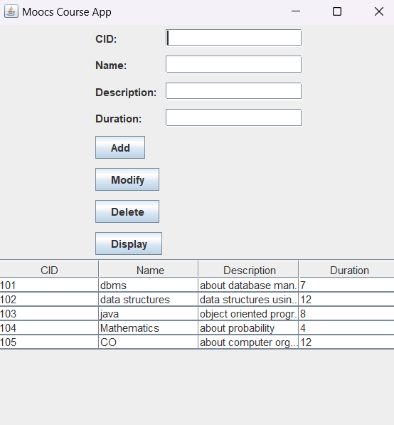

**7.RETREIVE:**

**Source code**

import java.awt.*;

import java.awt.event.*;

import javax.swing.*;

import java.sql.*;

public class Retreive {

private JLabel studentIdLabel;

private JTextField studentIdField;

private JButton retrieveButton;

public Retreive() {

// Set frame properties

JFrame frame = new JFrame("MOOCs Database Front End");

// frame.setDefaultCloseOperation(JFrame.EXIT_ON_CLOSE);

frame.setDefaultCloseOperation(JFrame.DISPOSE_ON_CLOSE);

frame.setLayout(new FlowLayout());

// Initialize components

studentIdLabel = new JLabel("Student ID:");

studentIdField = new JTextField(10);

retrieveButton = new JButton("Retrieve Grade");

// Add components to the frame

frame.add(studentIdLabel);

frame.add(studentIdField);

frame.add(retrieveButton);

// Add action listener to the retrieveButton

retrieveButton.addActionListener(new ActionListener() {

public void actionPerformed(ActionEvent e) {

int studentId = Integer.parseInt(studentIdField.getText());

retrieveGradeAndCertificateCount(studentId);

}

});

// Set frame properties

frame.pack();

frame.setLocationRelativeTo(null); // Center the frame on the screen

frame.setVisible(true);

}

private void retrieveGradeAndCertificateCount(int studentId) {

// Database connection parameters

String url = "jdbc:oracle:thin:@localhost:1521:xe";

String username = "abhignya";

String password = "abhignya";

// SQL query to retrieve the grade with the highest score and count of different certificates

String query = "SELECT g.gid, g.eid, g.certificatename, g.score, COUNT(*) AS certificate_count " +

"FROM grade g " +

"JOIN enrollement e ON g.eid = e.eid " +

"WHERE e.sid = ? " +

"GROUP BY g.gid, g.eid, g.certificatename, g.score " +

"HAVING g.score = (SELECT MAX(score) FROM grade WHERE eid = g.eid) " +

"ORDER BY g.score DESC";

try (Connection connection = DriverManager.getConnection(url, username, password);

PreparedStatement statement = connection.prepareStatement(query)) {

// Set the student ID as a parameter in the query

statement.setInt(1, studentId);

// Execute the query

ResultSet resultSet = statement.executeQuery();

StringBuilder resultBuilder = new StringBuilder();

boolean foundGrade = false;

while (resultSet.next()) {

int gradeId = resultSet.getInt("gid");

int enrollmentId = resultSet.getInt("eid");

String certificateName = resultSet.getString("certificatename");

int score = resultSet.getInt("score");

int certificateCount = resultSet.getInt("certificate_count");

resultBuilder.append("Grade ID: ").append(gradeId).append("\n");

resultBuilder.append("Enrollment ID: ").append(enrollmentId).append("\n");

resultBuilder.append("Certificate Name: ").append(certificateName).append("\n");

resultBuilder.append("Score: ").append(score).append("\n");

resultBuilder.append("Certificate Count: ").append(certificateCount).append("\n\n");

foundGrade = true;

}

if (foundGrade) {

JOptionPane.showMessageDialog(null, resultBuilder.toString(), "Grade and Certificate Details", JOptionPane.INFORMATION_MESSAGE);

} else {

JOptionPane.showMessageDialog(null, "No grade found for student ID: " + studentId, "Error", JOptionPane.ERROR_MESSAGE);

}

} catch (SQLException e) {

e.printStackTrace();

}

}

public static void main(String[] args) {

SwingUtilities.invokeLater(new Runnable() {

public void run() {

new Retreive();

}

});

}

}

OUTPUT:

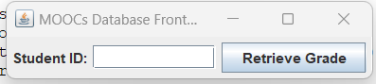

**8.TOPPER’S LIST:**

**Source code**

import javax.swing.*;

import javax.swing.table.DefaultTableModel;

import java.awt.*;

import java.sql.*;

public class ToppersList extends JFrame {

private static final long serialVersionUID = 1L;

private JTable tblToppers;

private JButton btnMarksToppers, btnCertificateToppers;

private Connection connection;

public ToppersList() {

initializeUI();

connectToDatabase();

setTitle("Toppers Details");

setDefaultCloseOperation(JFrame.DISPOSE_ON_CLOSE);

setSize(600, 400);

setVisible(true);

}

private void initializeUI() {

tblToppers = new JTable();

JScrollPane scrollPane = new JScrollPane(tblToppers);

btnMarksToppers = new JButton(" Toppers based on marks");

btnCertificateToppers = new JButton("Certificate_count");

JPanel panel = new JPanel(new BorderLayout());

panel.add(btnMarksToppers, BorderLayout.WEST);

panel.add(btnCertificateToppers, BorderLayout.EAST);

setLayout(new BorderLayout());

add(panel, BorderLayout.NORTH);

add(scrollPane, BorderLayout.CENTER);

btnMarksToppers.addActionListener(e -> generateMarksToppersReport());

btnCertificateToppers.addActionListener(e -> generateCertificateToppersReport());

setTitle("Toppers List");

pack();

setLocationRelativeTo(null);

setVisible(true);

}

private void connectToDatabase() {

String url = "jdbc:oracle:thin:@localhost:1521:xe";

String username = "abhignya";

String password = "abhignya";

try {

connection = DriverManager.getConnection(url, username, password);

} catch (SQLException e) {

e.printStackTrace();

}

}

private void generateMarksToppersReport() {

try {

String query = "SELECT g.gid, g.eid, g.certificatename, g.score " +

"FROM (SELECT * FROM grade ORDER BY score DESC) g " +

"INNER JOIN enrollement e ON g.eid = e.eid " +

"WHERE ROWNUM <= 10";

Statement statement = connection.createStatement();

ResultSet resultSet = statement.executeQuery(query);

DefaultTableModel model = new DefaultTableModel();

model.setColumnIdentifiers(new String[]{"Grade ID", "Enrollment ID", "Certificate Name", "Score"});

while (resultSet.next()) {

String gid = resultSet.getString("gid");

String eid = resultSet.getString("eid");

String certificateName = resultSet.getString("certificatename");

String score = resultSet.getString("score");

model.addRow(new String[]{gid, eid, certificateName, score});

}

tblToppers.setModel(model);

} catch (SQLException e) {

e.printStackTrace();

}

}

private void generateCertificateToppersReport() {

try {

String query = "SELECT * " +

"FROM (SELECT g.certificatename, COUNT(*) as certificate_count " +

" FROM grade g " +

" GROUP BY g.certificatename " +

" ORDER BY certificate_count DESC) " +

"WHERE ROWNUM <= 10";

Statement statement = connection.createStatement();

ResultSet resultSet = statement.executeQuery(query);

DefaultTableModel model = new DefaultTableModel();

model.setColumnIdentifiers(new String[]{"Certificate Name", "Certificate Count"});

while (resultSet.next()) {

String certificateName = resultSet.getString("certificatename");

String certificateCount = resultSet.getString("certificate_count");

model.addRow(new String[]{certificateName, certificateCount});

}

tblToppers.setModel(model);

} catch (SQLException e) {

e.printStackTrace();

}

}

public static void main(String[] args) {

SwingUtilities.invokeLater(ToppersList::new);

}

}

OUTPUT:

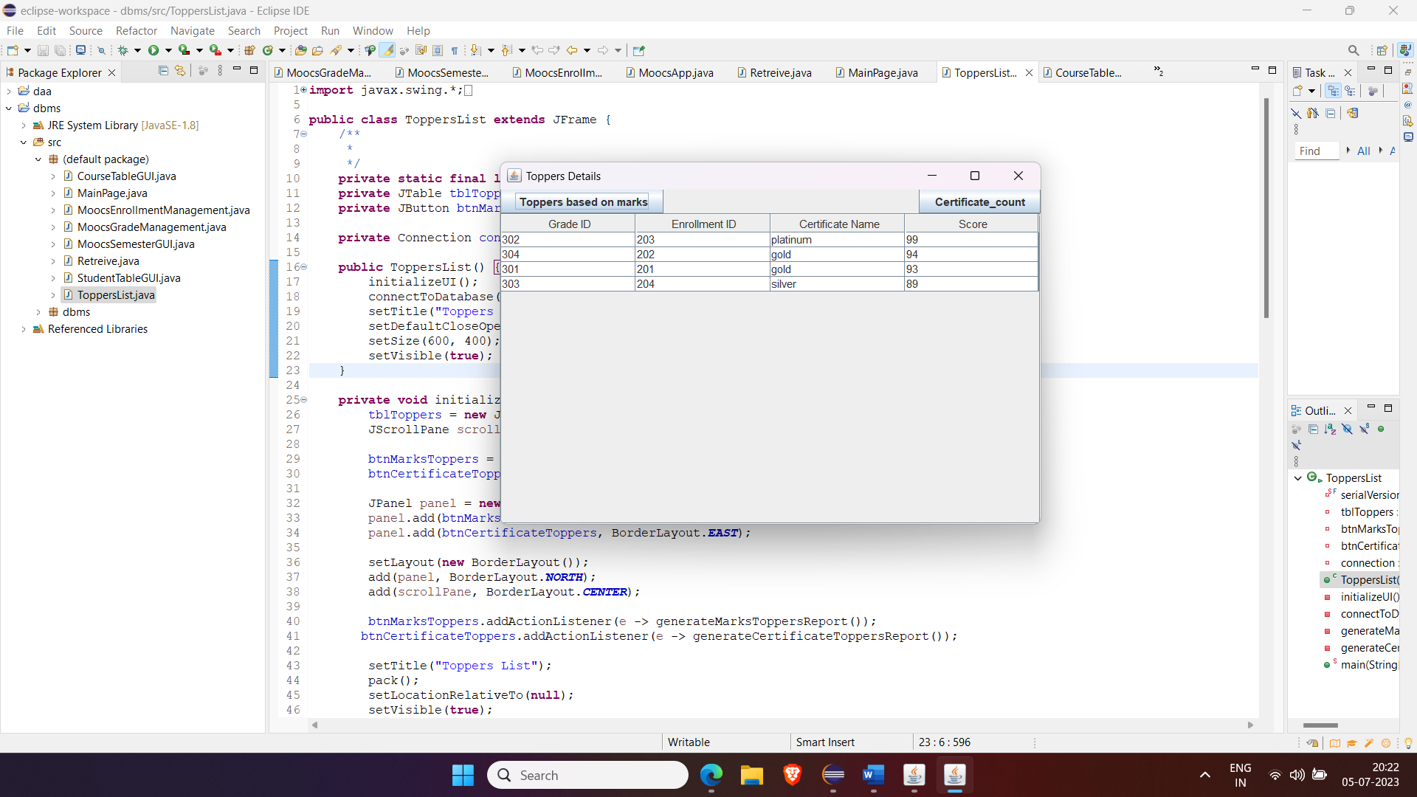

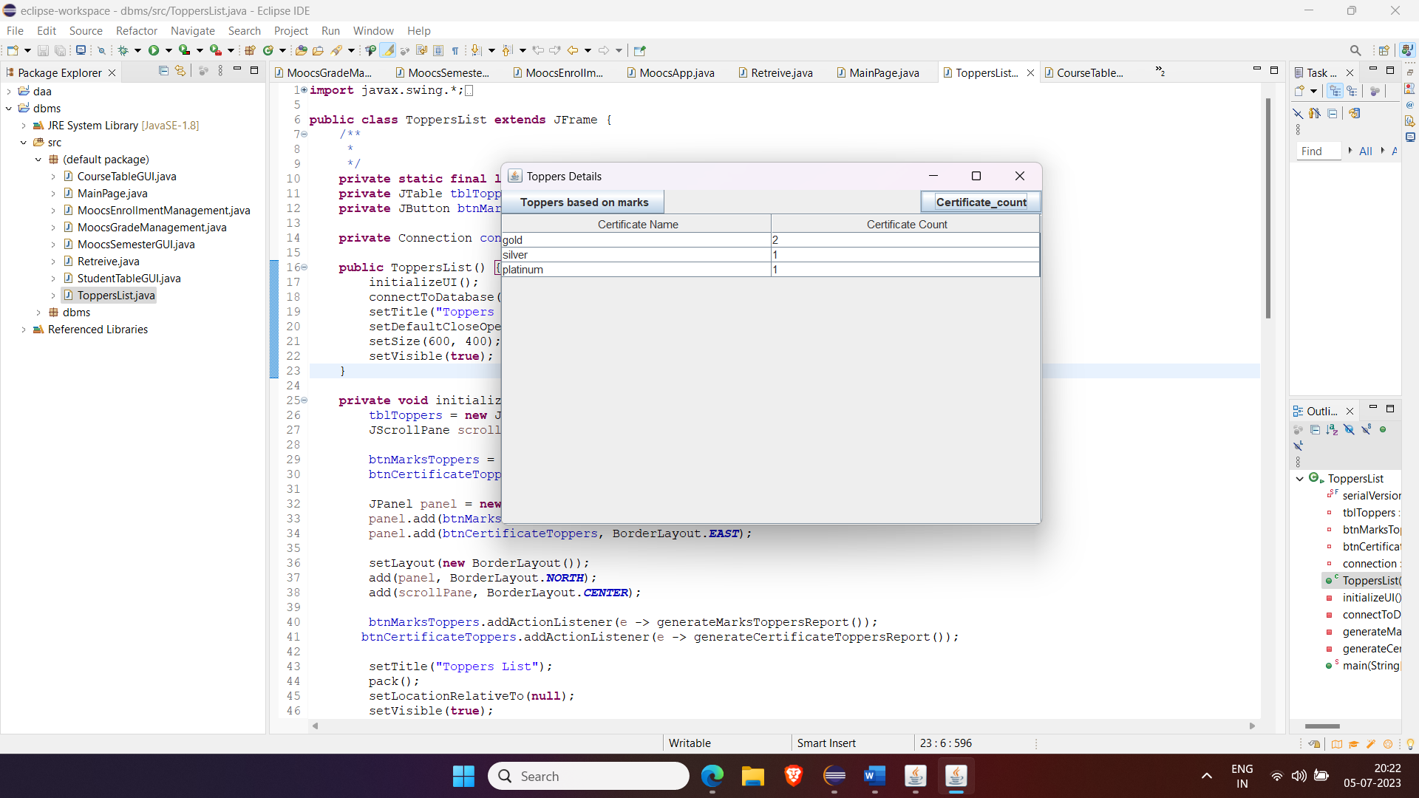

**TESTING**

Student Details:

Before Inserting

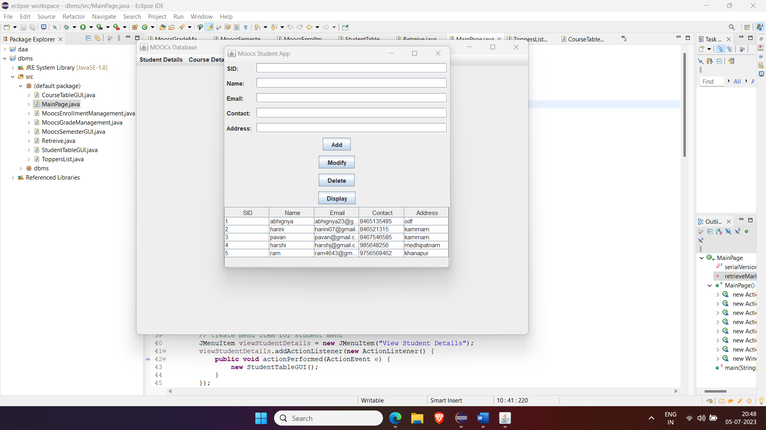

After Inserting

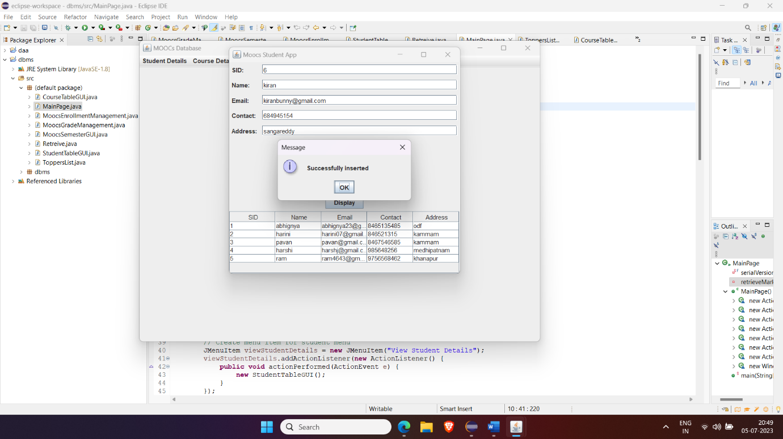

Deleting:

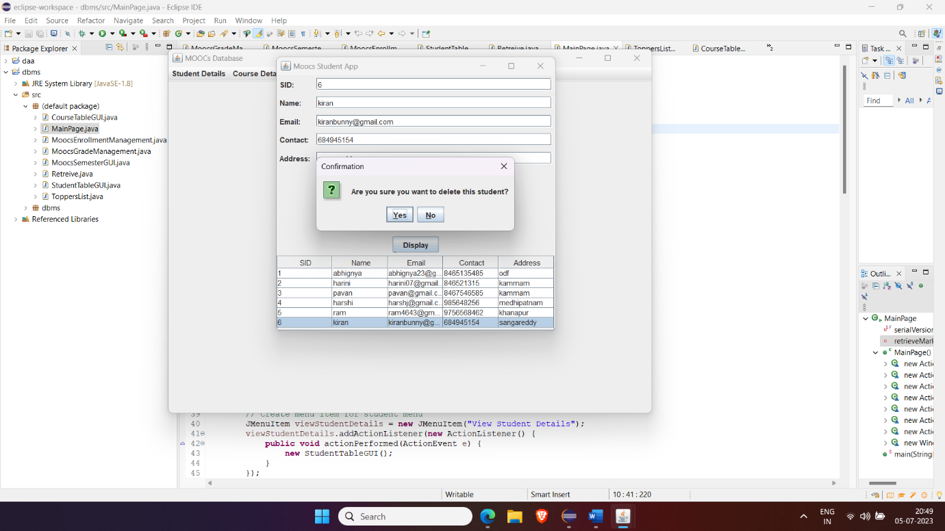

After Modifying:

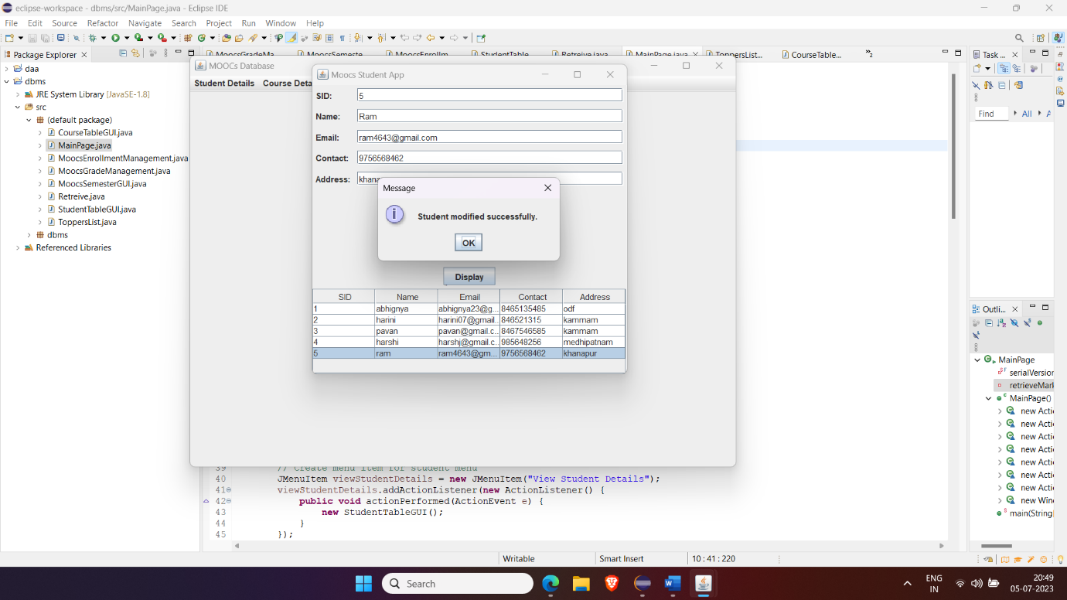

Course details:

Before Inserting

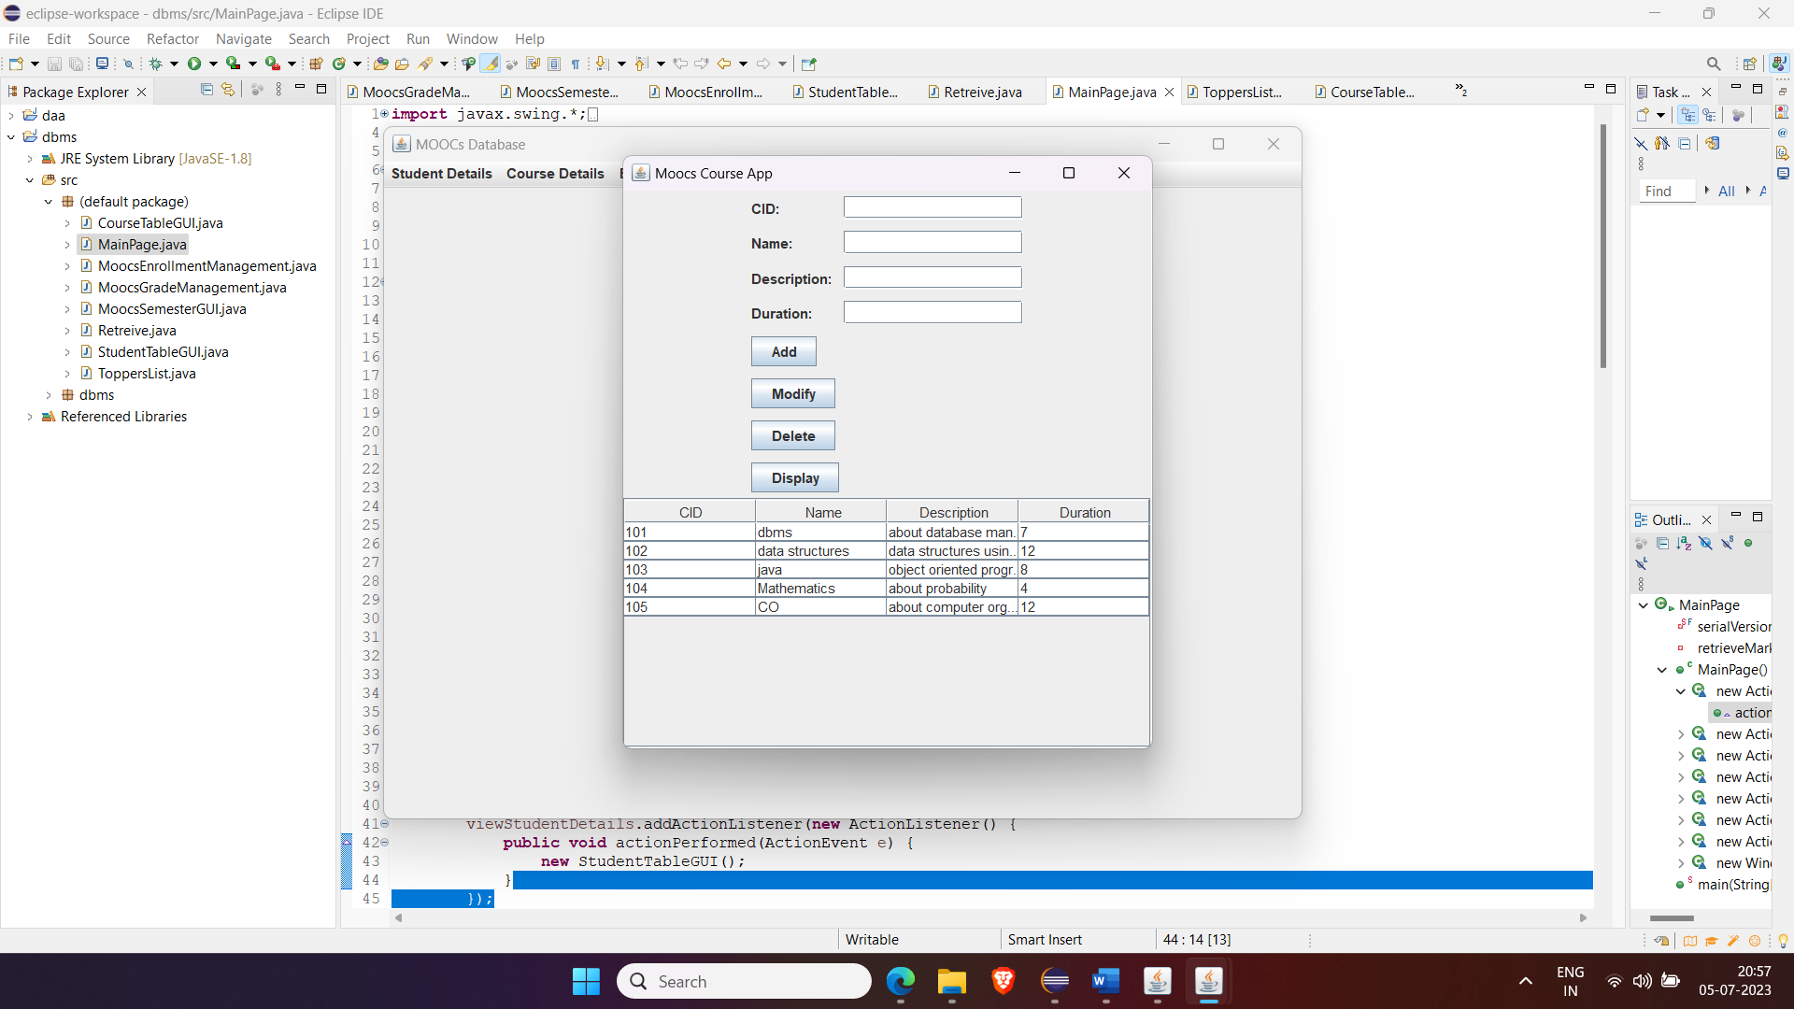

After Inserting:

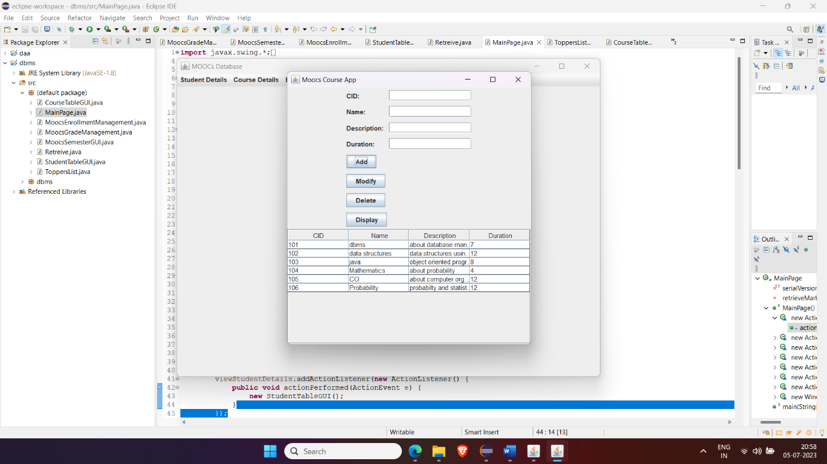

Before Deleting:

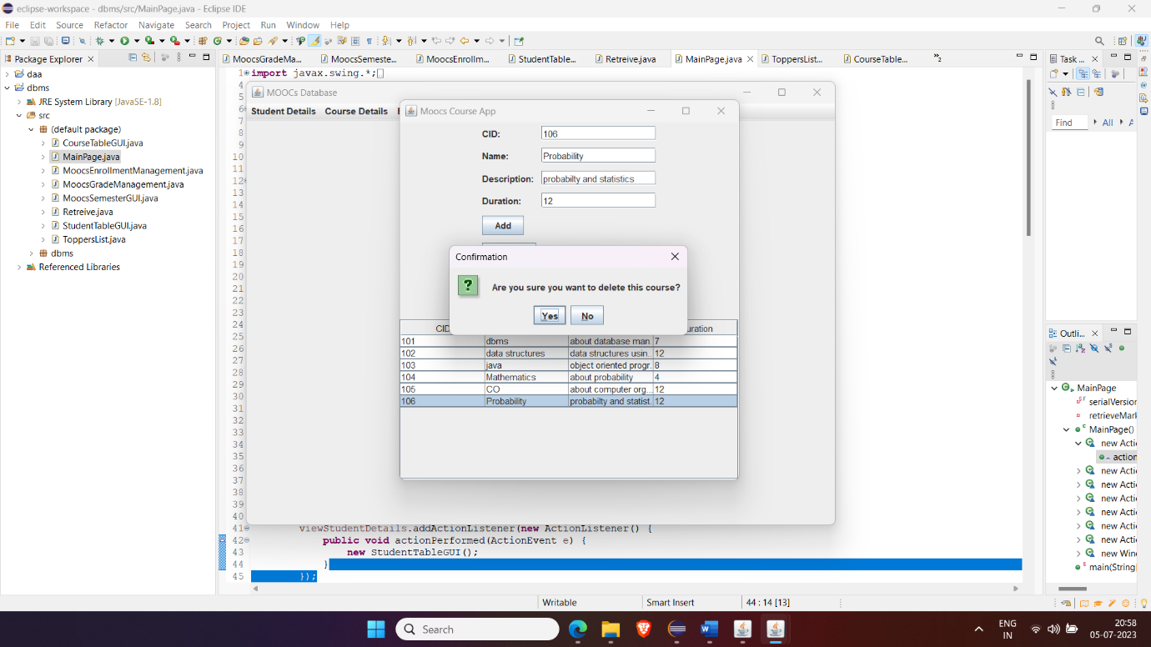

After Deleting:

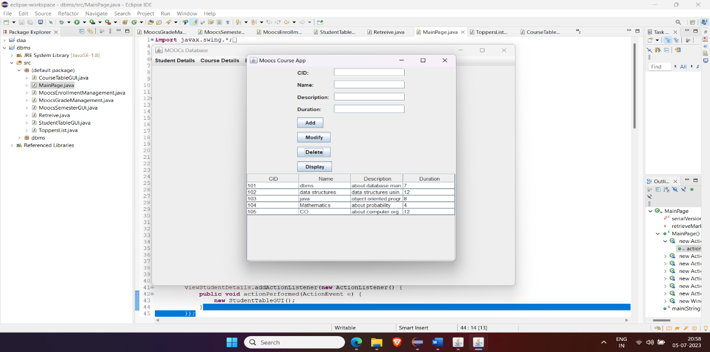

Before Modifying:

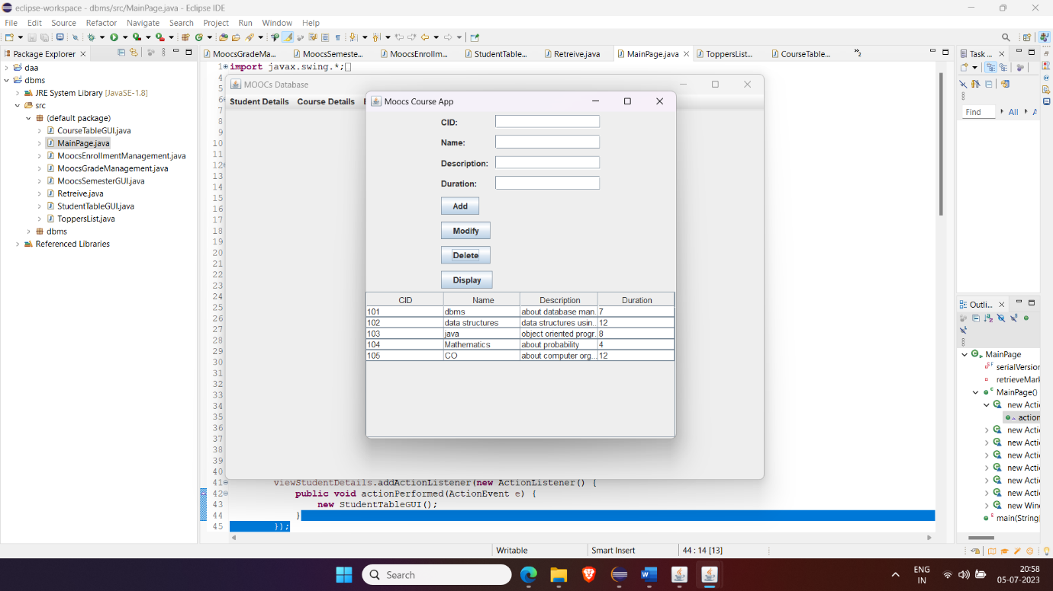

After Modifying:

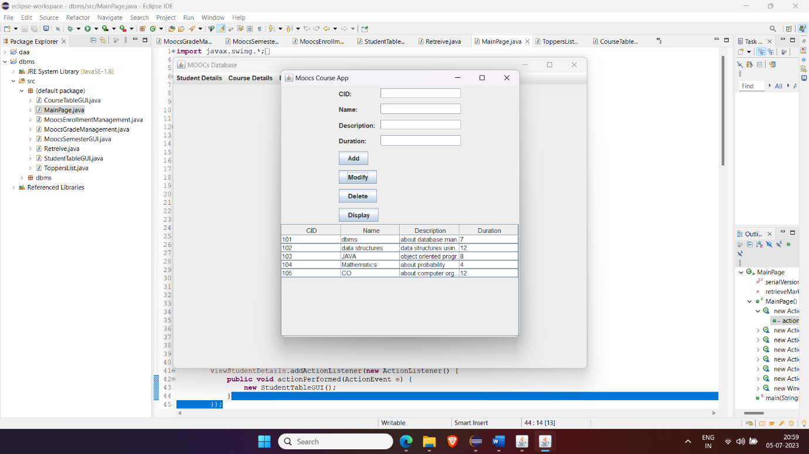

Enrollement Details:

Before Inserting

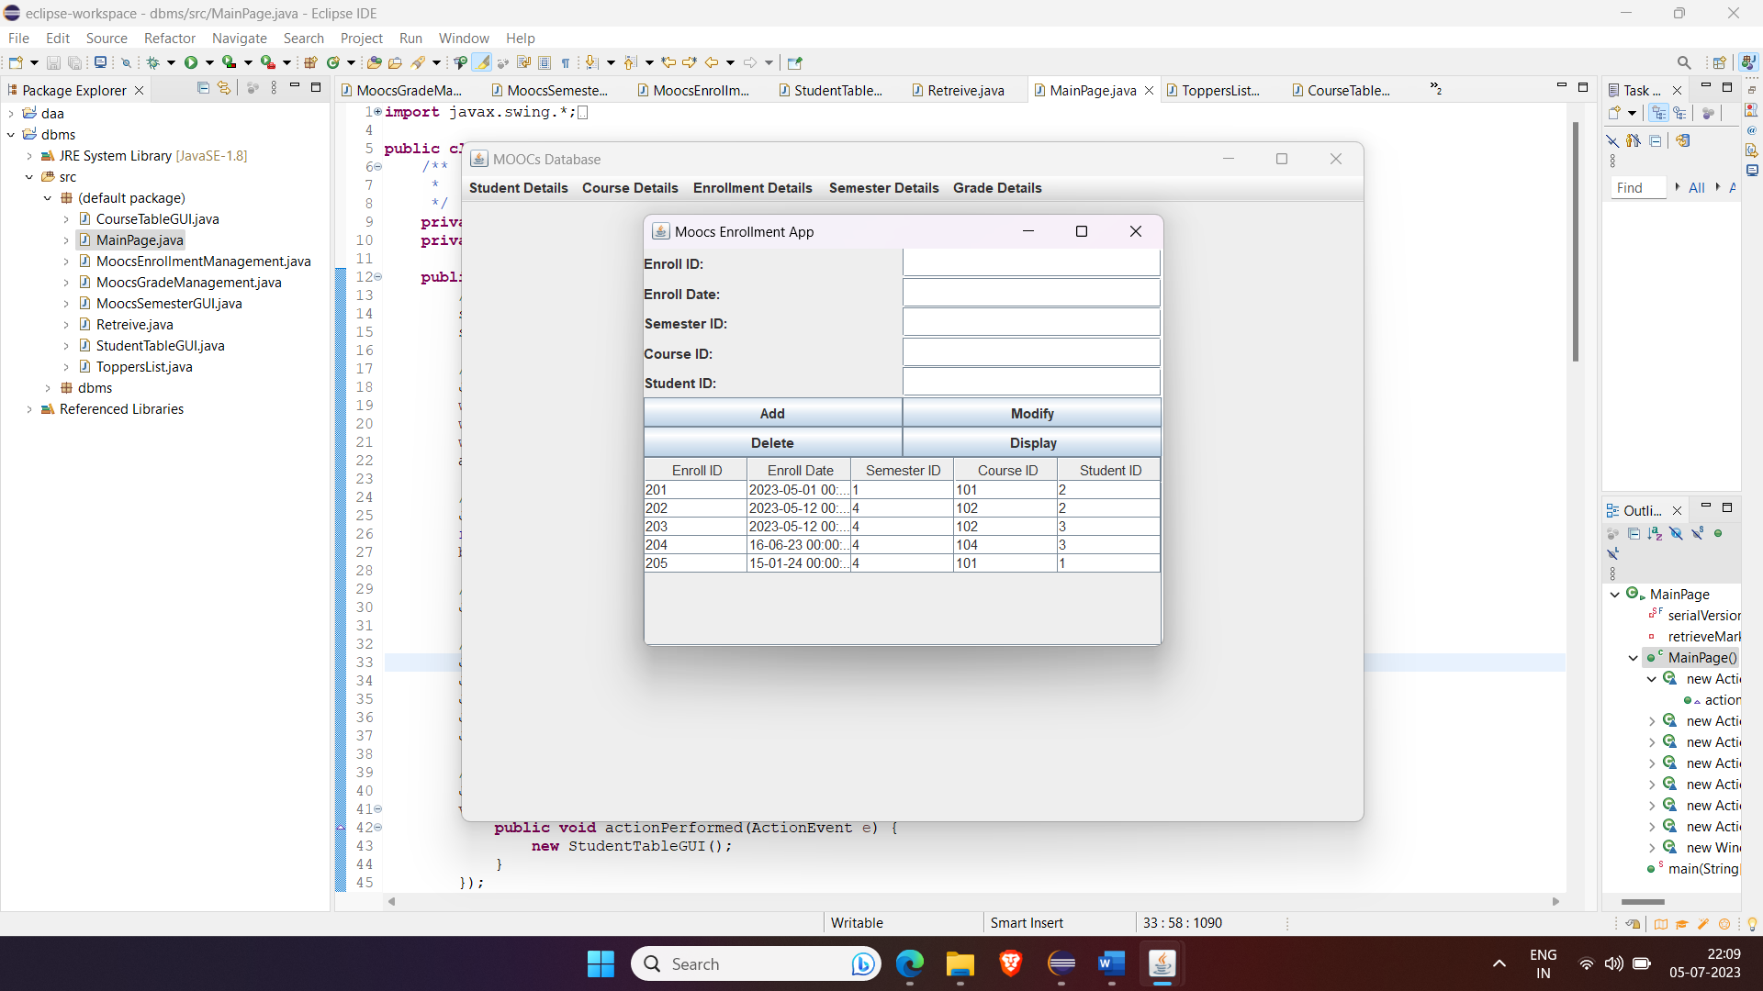

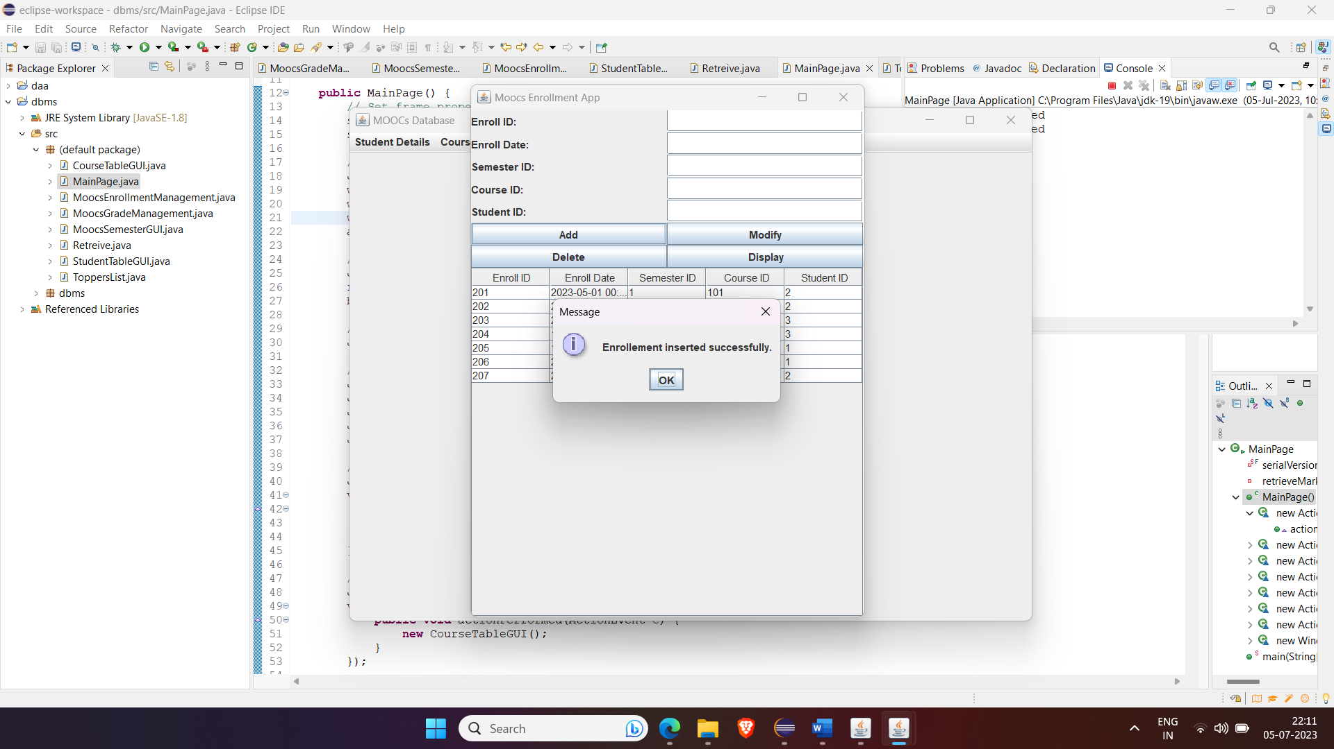

Updating

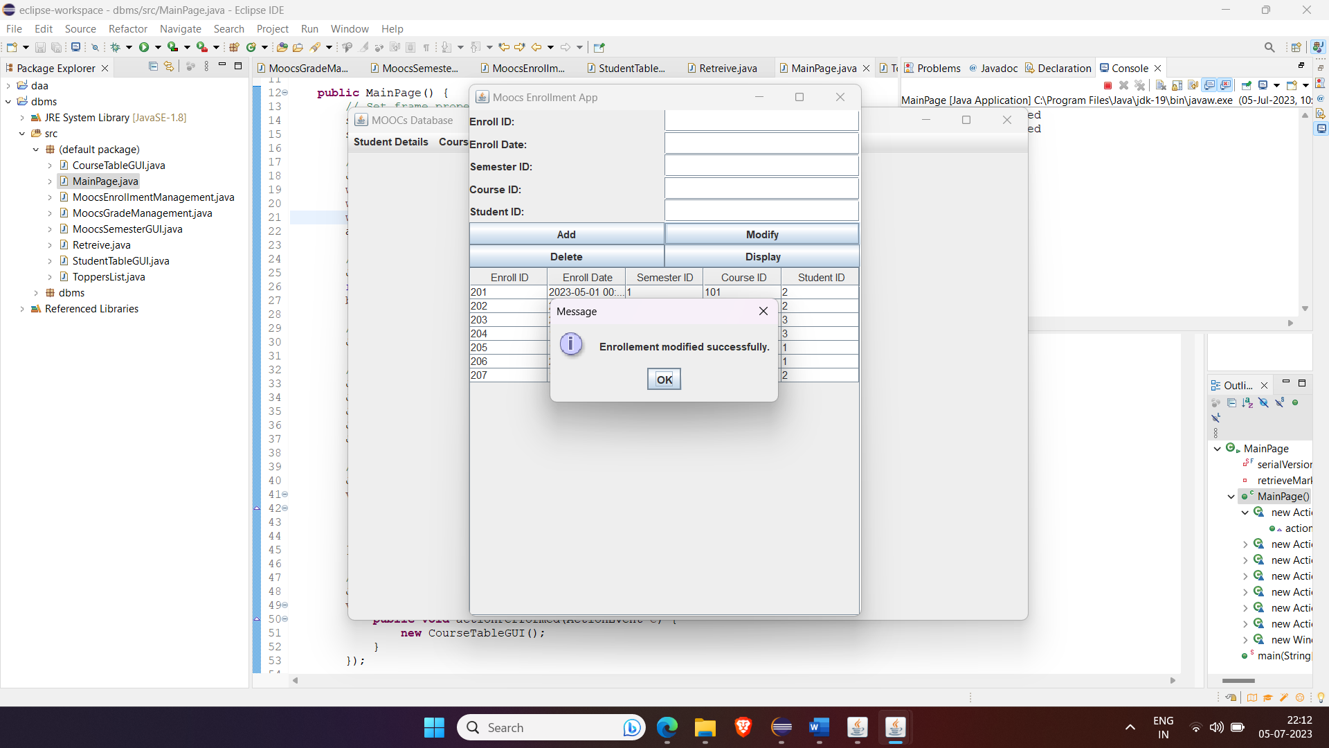

Deleting:

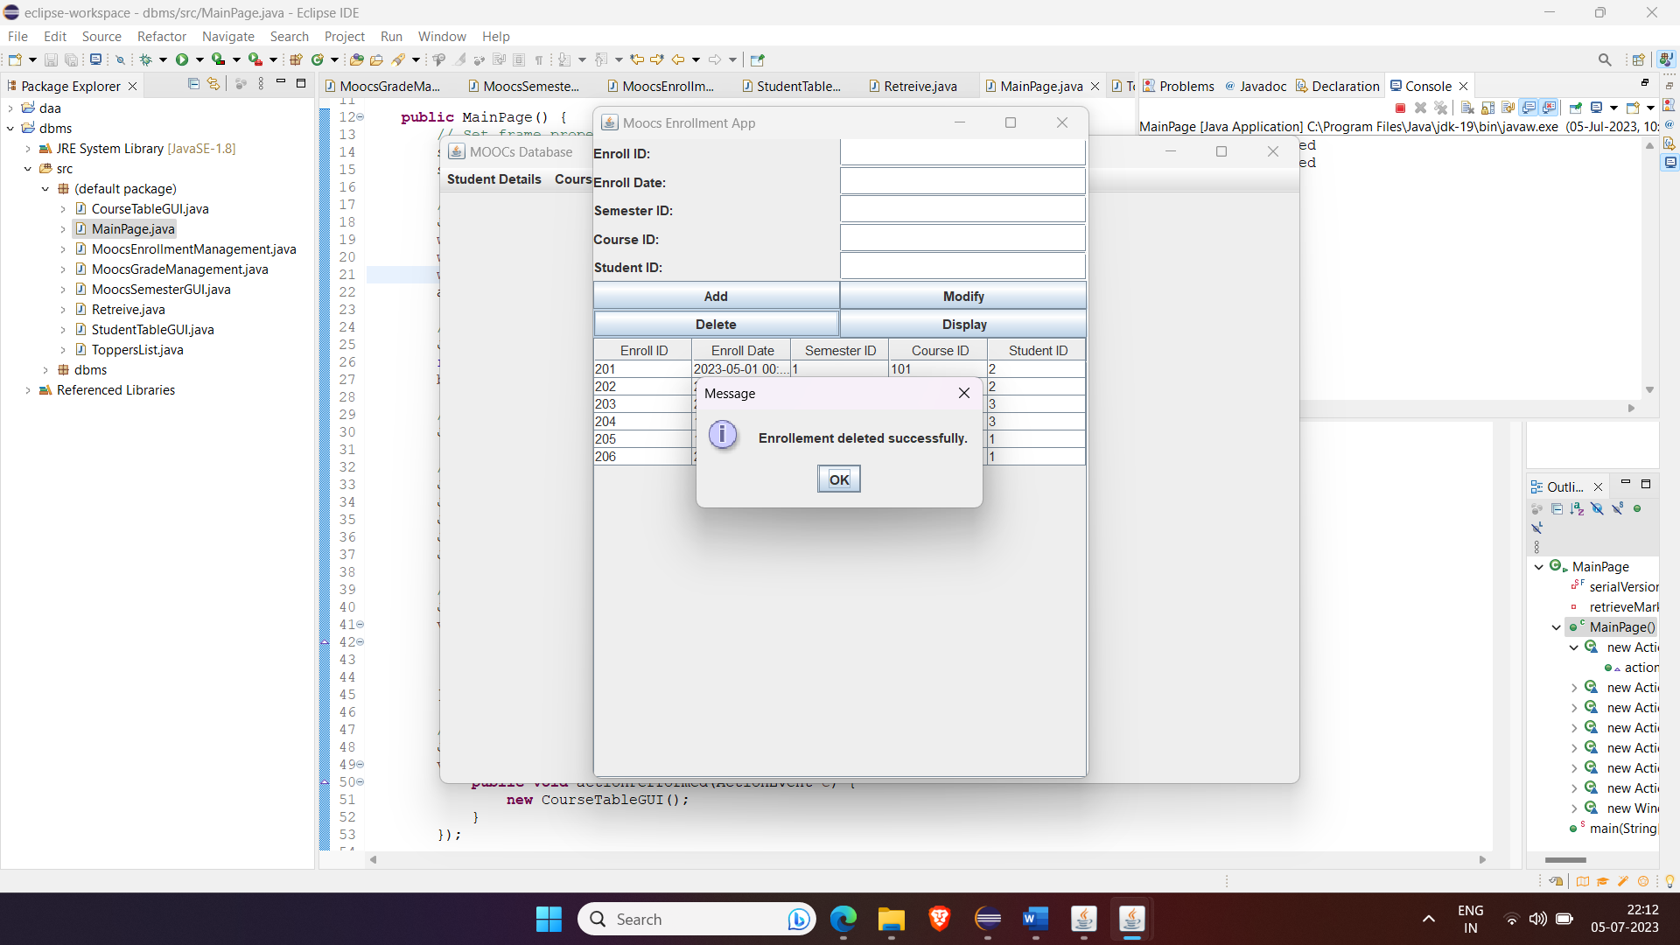

Semester Details:

Before Inserting:

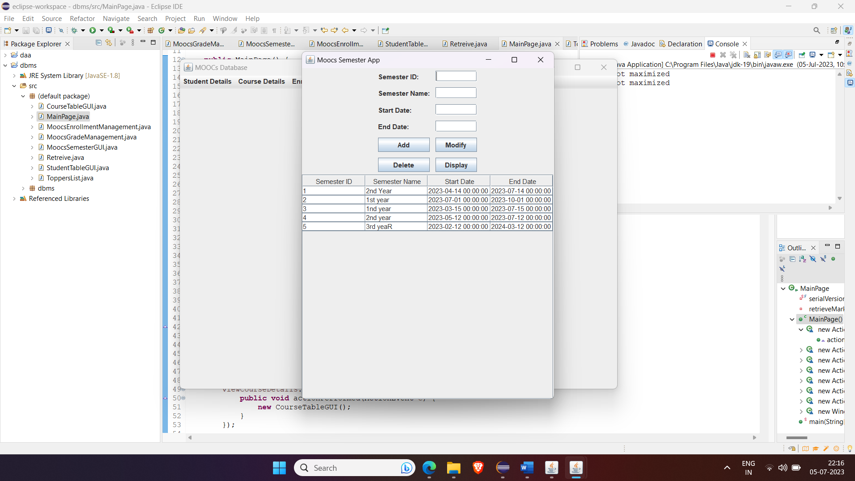

After Inserting:

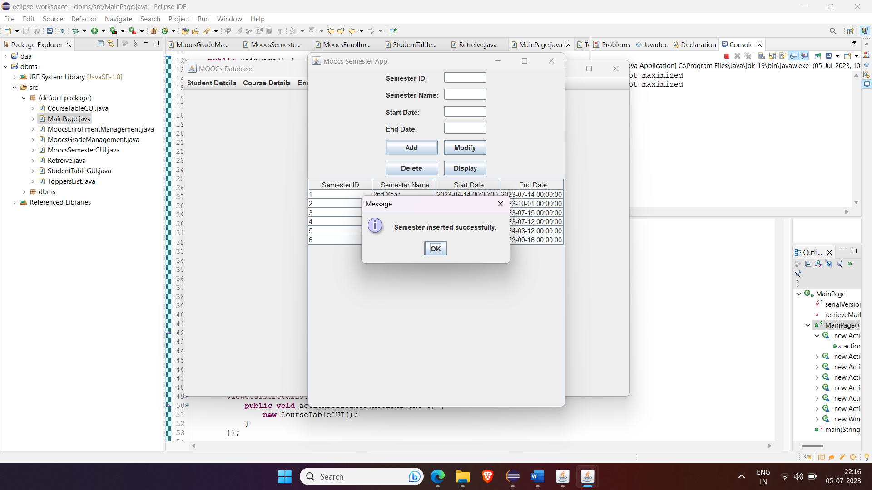

Updating:

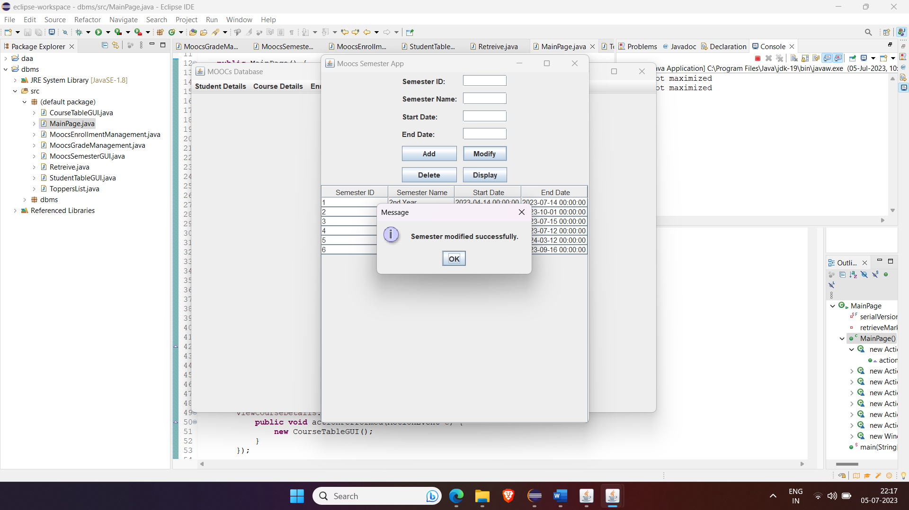

Before Deleting:

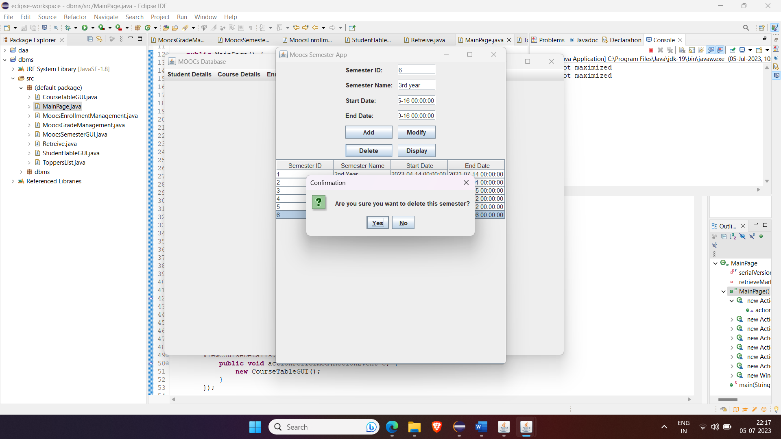

After deleting:

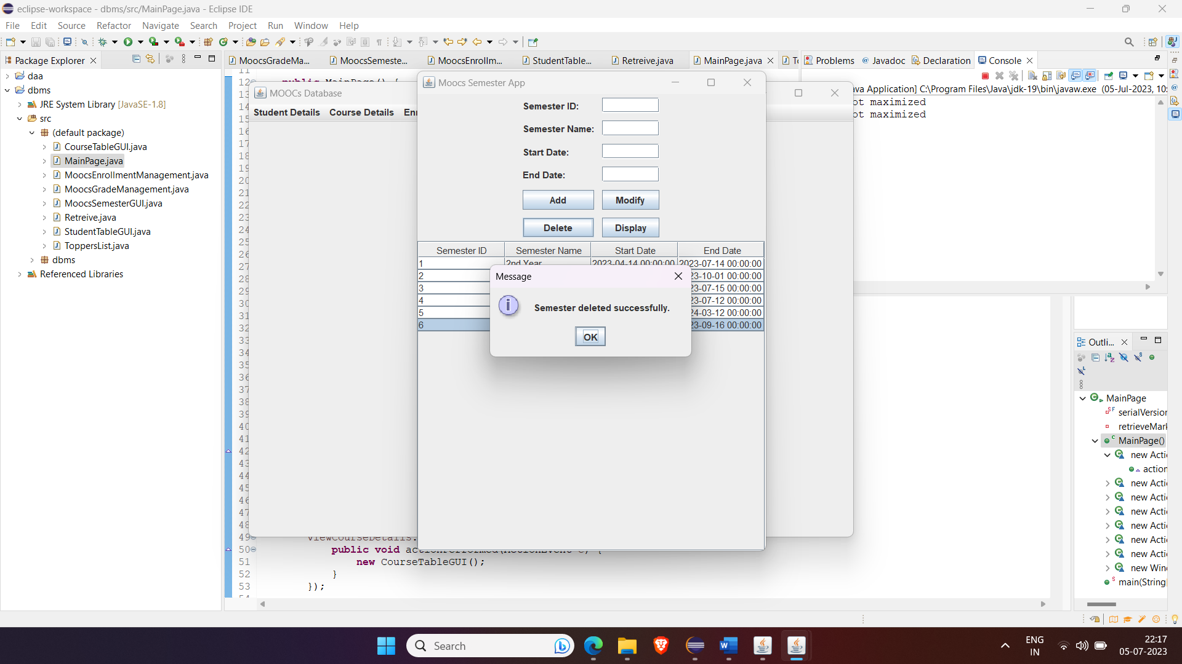

Grade Details:

Before Inserting:

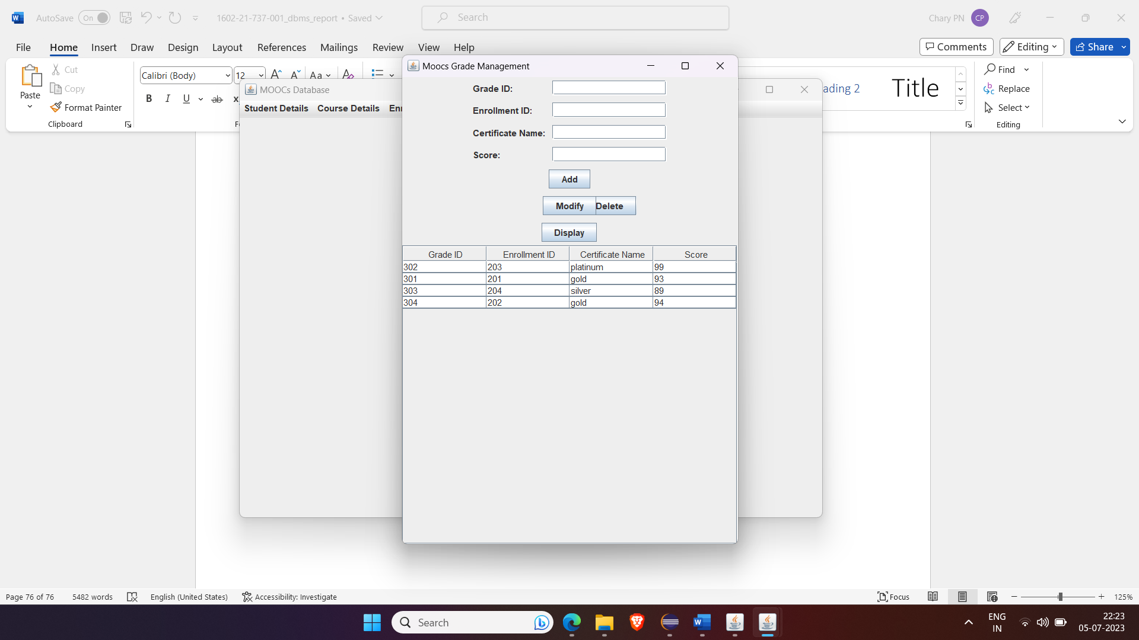

After Inserting:

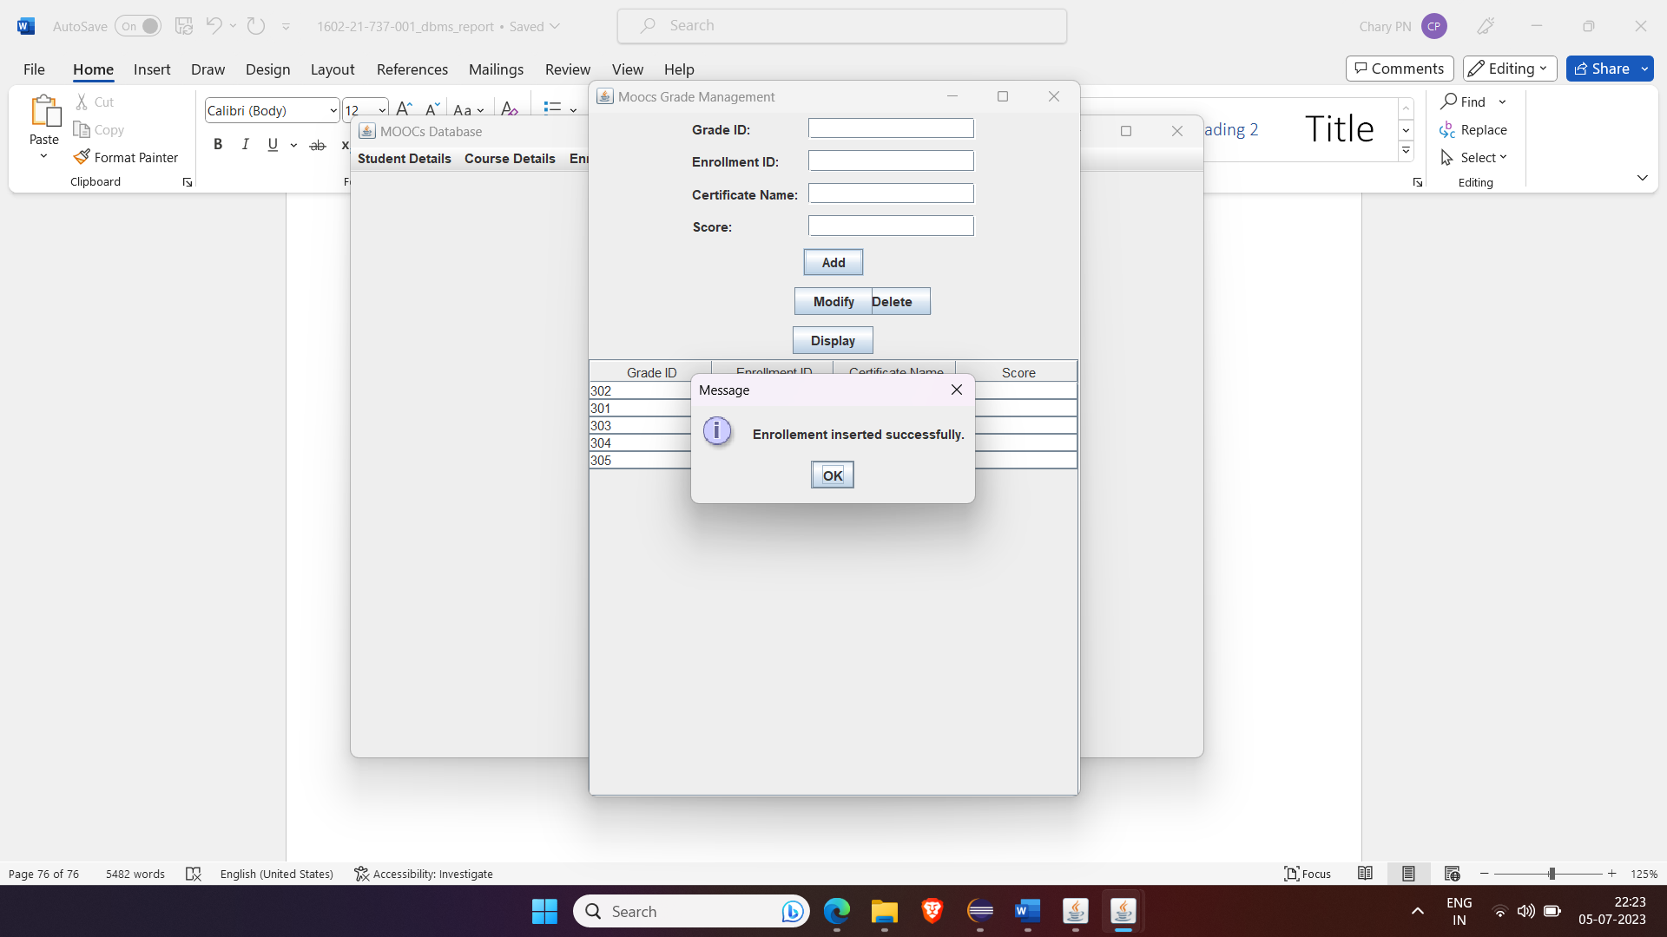

Updating:

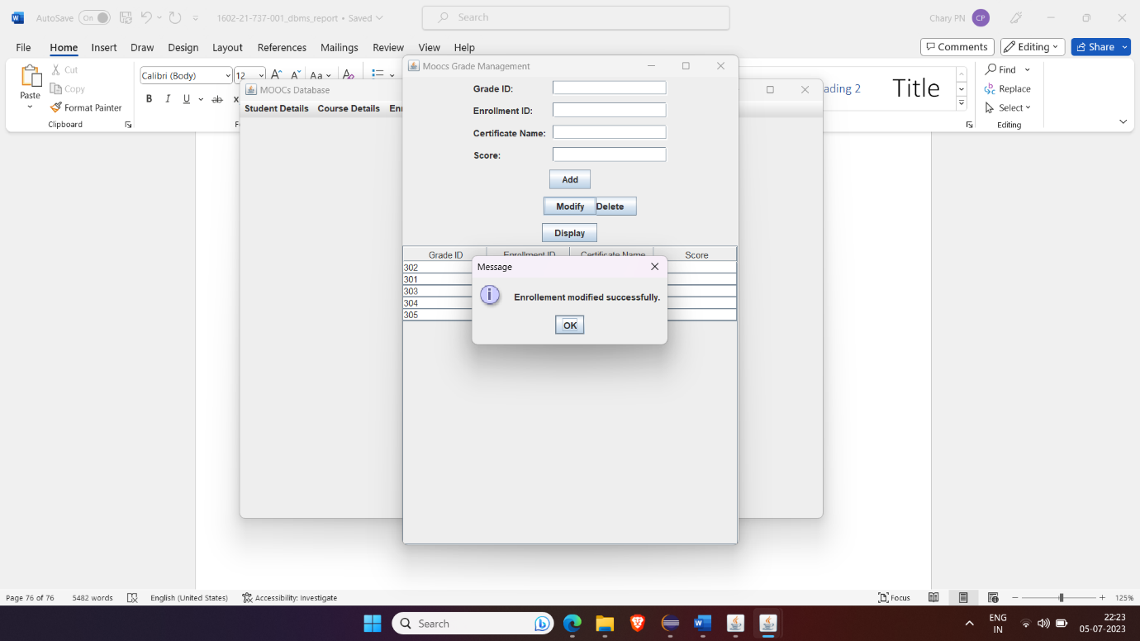

Before deleting:

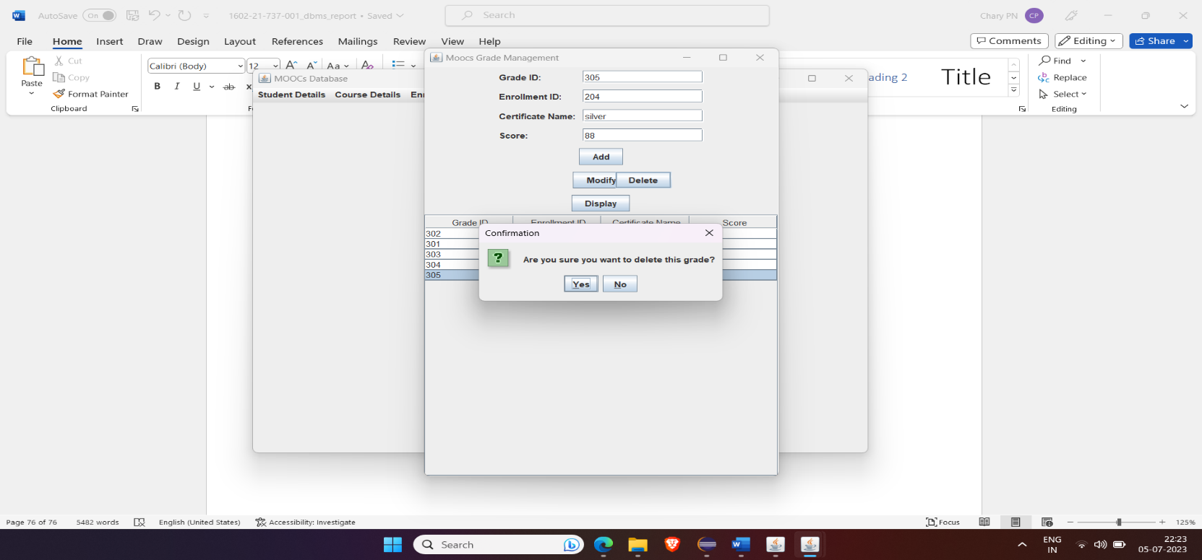

After deleting:

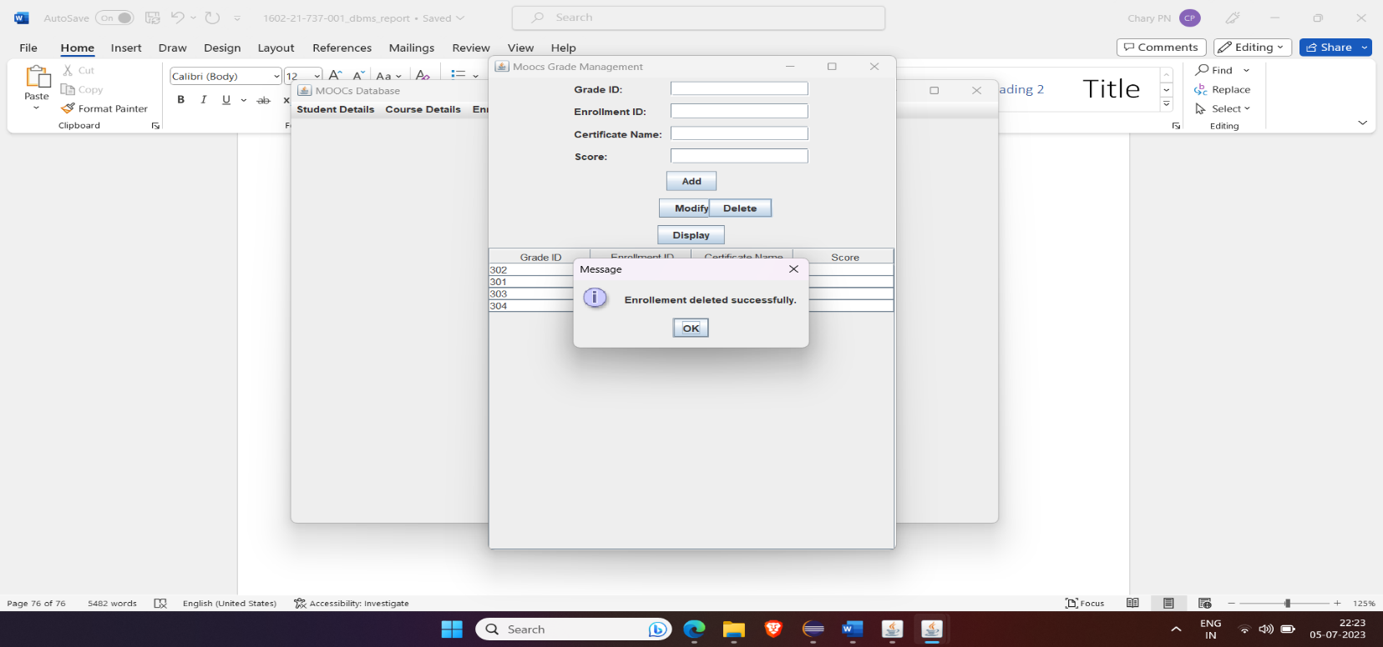

Toppers Details:

Based on Marks:

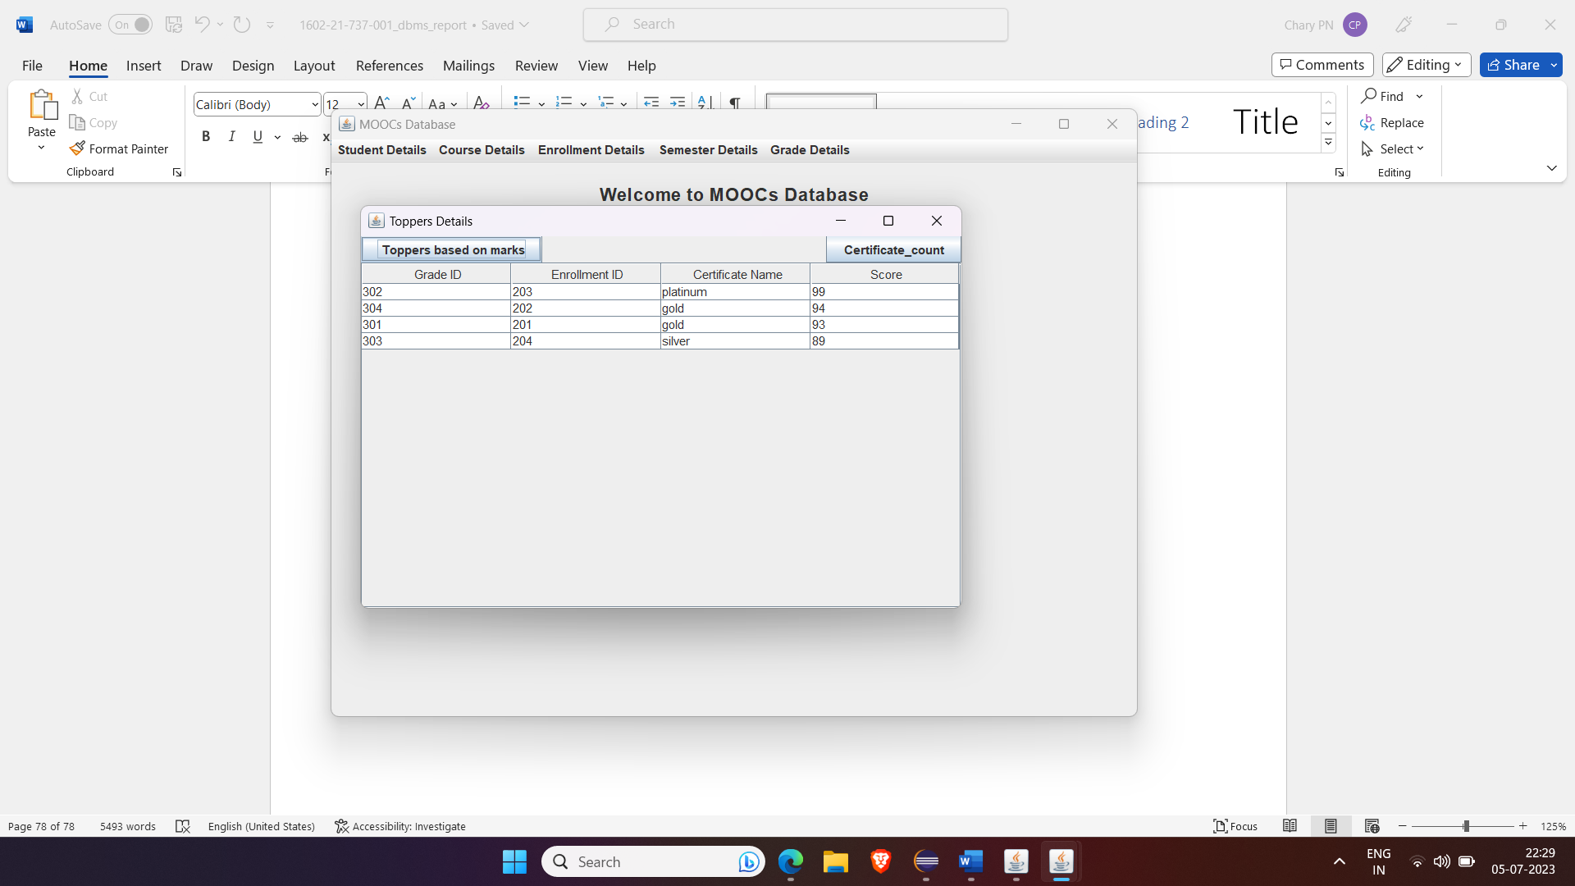

Certificate count:

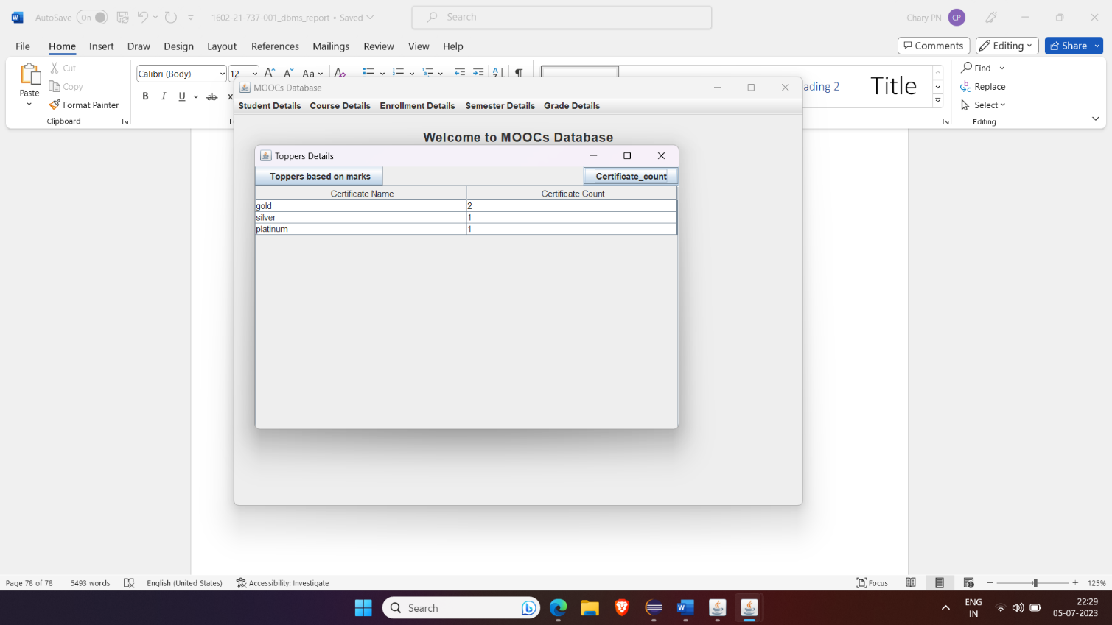

Retrieve Data:

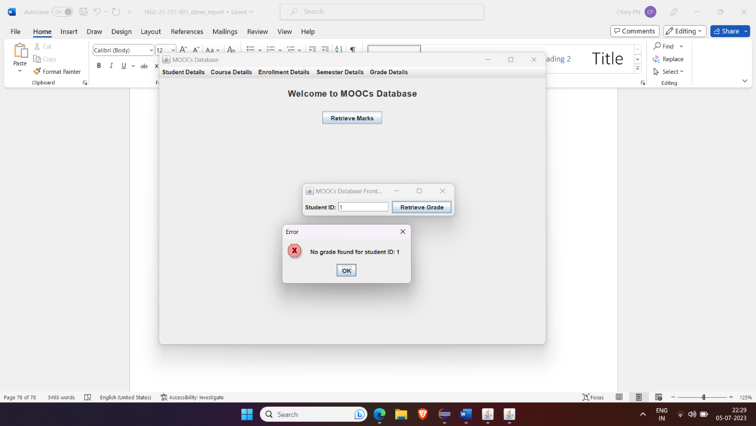

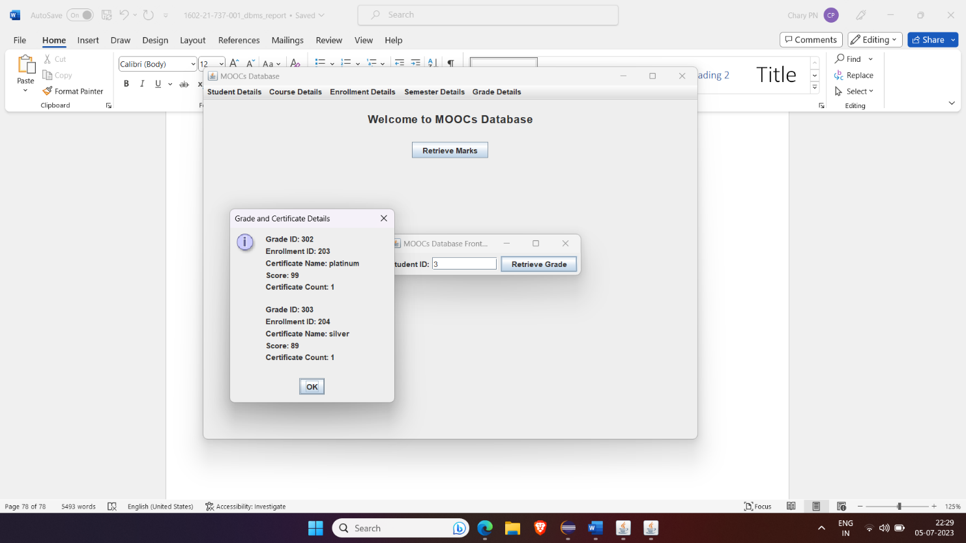

**RESULT**

I have successfully completed my DBMS project ‘***MOOC Database***’

**DISCUSSION AND FUTURE WORK**

This project is an application which helps the students access their highest-grade points from all the courses they have been certified for. It has a very basic user interface. Future scope would be to make the UI more appealing by using graphics. One more feature would be to allow student-users to upload their resumes and official documents required so that the project managers can take a look while they hire them during internship process or placements. We can also think of including a feedback system to allow the users to leave their valuable feedback after using this app. Making this feedback to be publicly viewable, would attract many more users to use this app.

**REFERENCES**

● https://docs.oracle.com/javase/7/docs/api/

● <https://www.javatpoint.com/java-swing>

● https://stackoverflow.com/

**GITHUB LINK:**

https://github.com/Abhignya06/MoocsDatabaseForStudents